

**Implementation of Java-Based Cashier System for**

**Fast Food Shop at Goldchick**

Written by:

1. Techi Kariska Sari (2320010287)
2. Leann Nataly Kenan Pakpahan (2320010227)

**CEP CCIT**

**FAKULTAS TEKNIK UNIVERSITAS INDONESIA**

**2024**

**PROJECT ON**

**Implementation of Java-Based Cashier System for Fast Food Shop at Goldchick**

**Developed by**

1. **Leann Nataly Kenan Pakpahan**
2. **Techi Kariska Sari**



**Implementation of Java-Based Cashier System for Fast Food Shop at Goldchick**

Batch Code : 2SE4

Start Date : April ${26}^{th}$,2024  
End Date : May $8^{th}$, 2024

Name of Faculty : Ir. Feri Nugroho, S.ST., M.IT.

Names of Developer :

1. Leann Nataly Kenan Pakpahan
2. Techi Kariska Sari

Date of Submission: April ${19}^{th}$, 2024

**CERTIFICATE**

This is to certify that this report titled “Implementation of Java-Based Cashier System for Fast Food Shop at Goldchick” embodies the original work done by Leann Nataly Kenan Pakpahan and Techi Kariska Sari. Project in partial fulfillment of their course requirement at NIIT.

Coordinator:

CEP CCIT



**ACKNOWLEDGEMENT**

We are grateful to Allah, the Almighty God, for giving us the abilities to fulfill our work without incident. Blessings and greetings are also sent to Muhammad SAW, our final and greatest prophet. Not to mention, we are grateful for our parents who have continued to support us both morally and financially till this point. We would like to thank Ir. Feri Nugroho, S.ST., M.IT.. as our supervisor who always helps us to finish this paper. Also acknowledged are our friends who have assisted us up until quite recently.

This paper was prepared to fulfill our project assignment as CEP CCIT FTUI students. The topic that will be discussed in this paper mechanism of how Implementation of Self-Ordering Kiosk System at Goldchick Restaurant Using Java. We hope this paper will be beneficial to all those who read, especially in education of information technology.

The author realizes that this paper is far from perfect, so it will be very helpful if colleagues and supervisors are willing to provide suggestions and criticism for the perfection of this paper.

**SYSTEM ANALYSIS**

**System Summary**:

Goldchick is a popular Indonesian food brand that specializes in serving a dish known as "Ayam Geprek." Ayam Geprek is a type of Indonesian fried chicken that's smashed and typically served with spicy sambal (chili paste) or other flavorful toppings. The dish has gained significant popularity in Indonesia and is known for its spicy and savory flavors.

The Java-Based Cashier System for Goldchick Fast Food Shop is designed to streamline the transaction process at the establishment. Built using the Java programming language, the system comprises several key components. Firstly, it features a user-friendly graphical user interface (GUI) utilizing Java Swing, making it easy for cashiers to operate the system. Data such as menu listings, transactions, and inventory are stored in a relational database such as MySQL, ensuring data security and accessibility. Behind the scenes, program logic is implemented to handle core functions such as transaction processing, inventory management, and payment total calculations. Integration with additional hardware peripherals like printers and barcode scanners further enhances efficiency. Data security measures are implemented to safeguard sensitive information. Consequently, the Java-Based Cashier System is expected to improve efficiency and provide a better experience for both cashiers and customers at Goldchick.

**DIAGRAM CLASS**

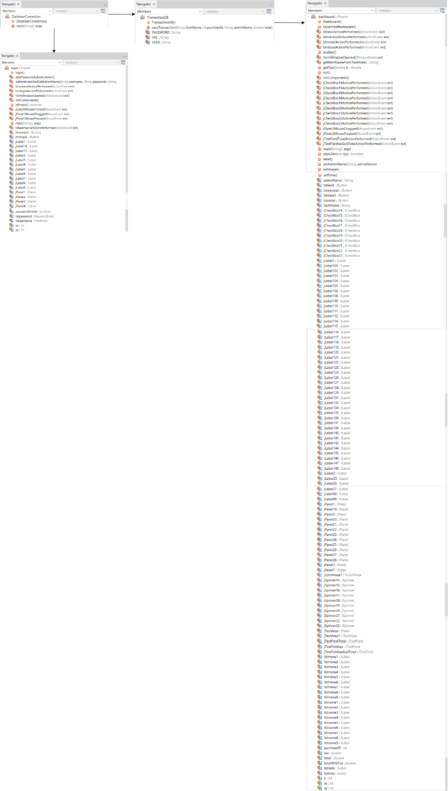

**DIAGRAM CLASS**



* The TransactionDB class owns or uses the ConnectionDatabase class. TransactionDB requires ConnectionDatabase to perform database operations such as insert, update, and delete.
* There is no direct relationship between ConnectionDatabase and DashboardJFrame.
* The LoginForm class owns or uses the ConnectionDatabase class. LoginForm requires ConnectionDatabase to verify user login with the database.

**SYSTEM PROCESS**

1. **Login**

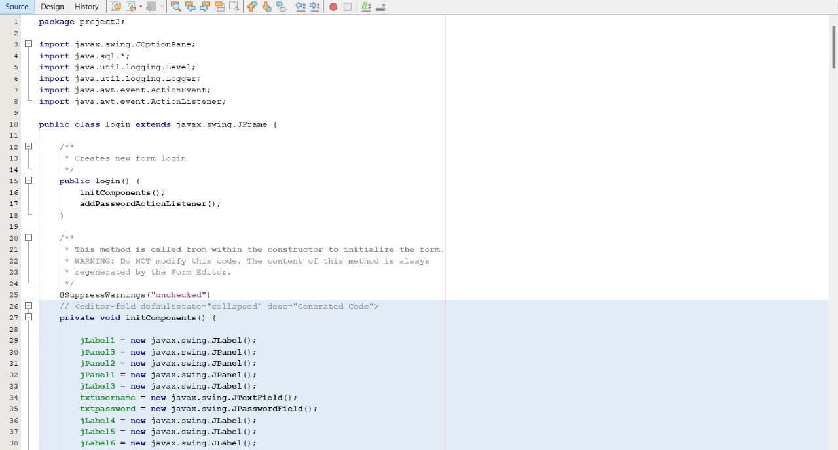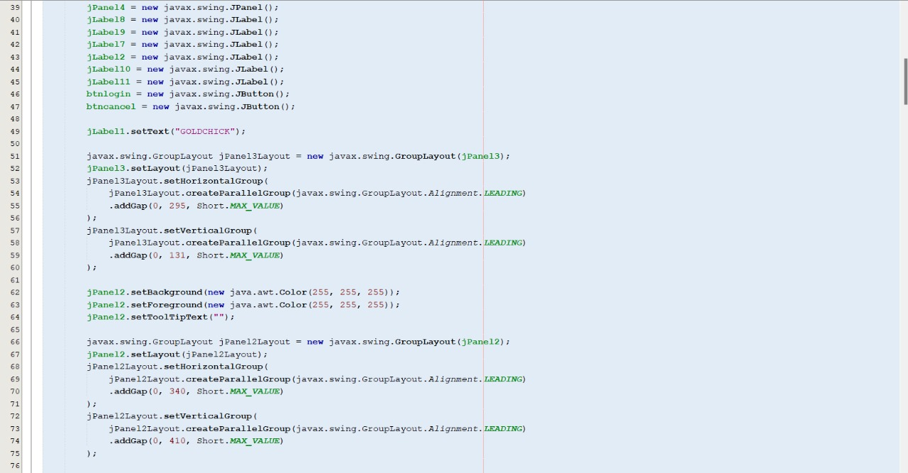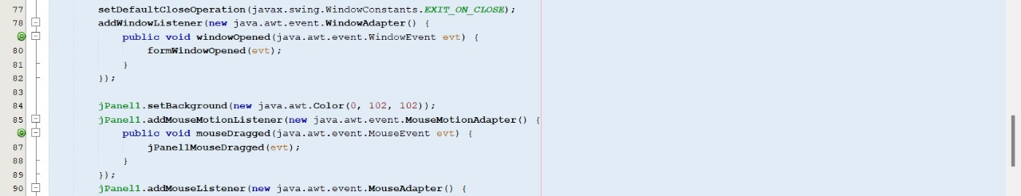

**SYSTEM PROCESS**

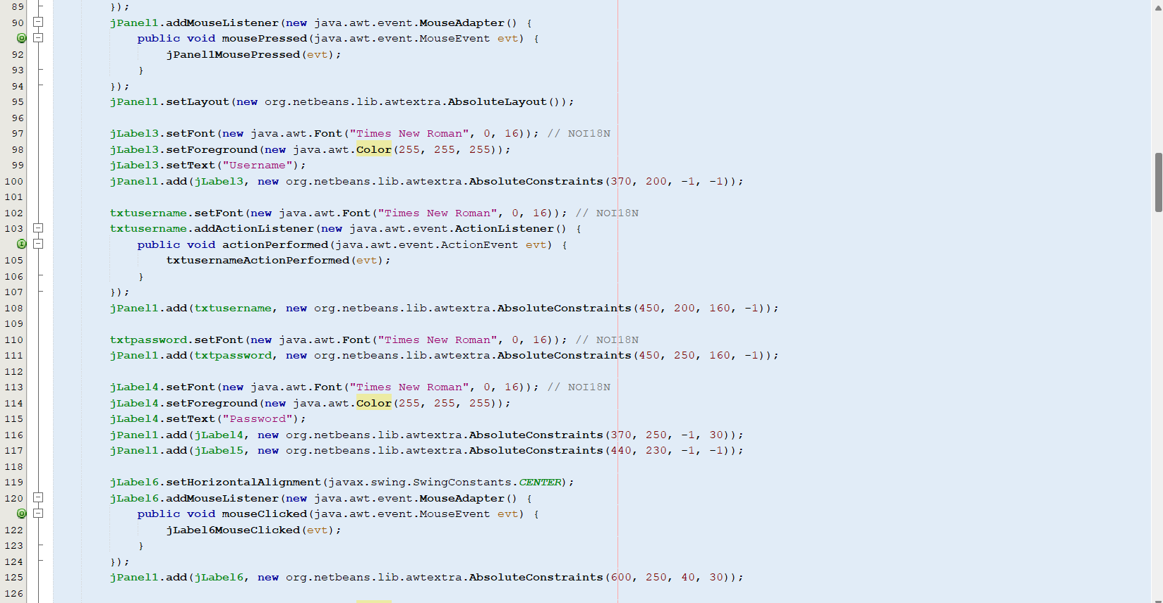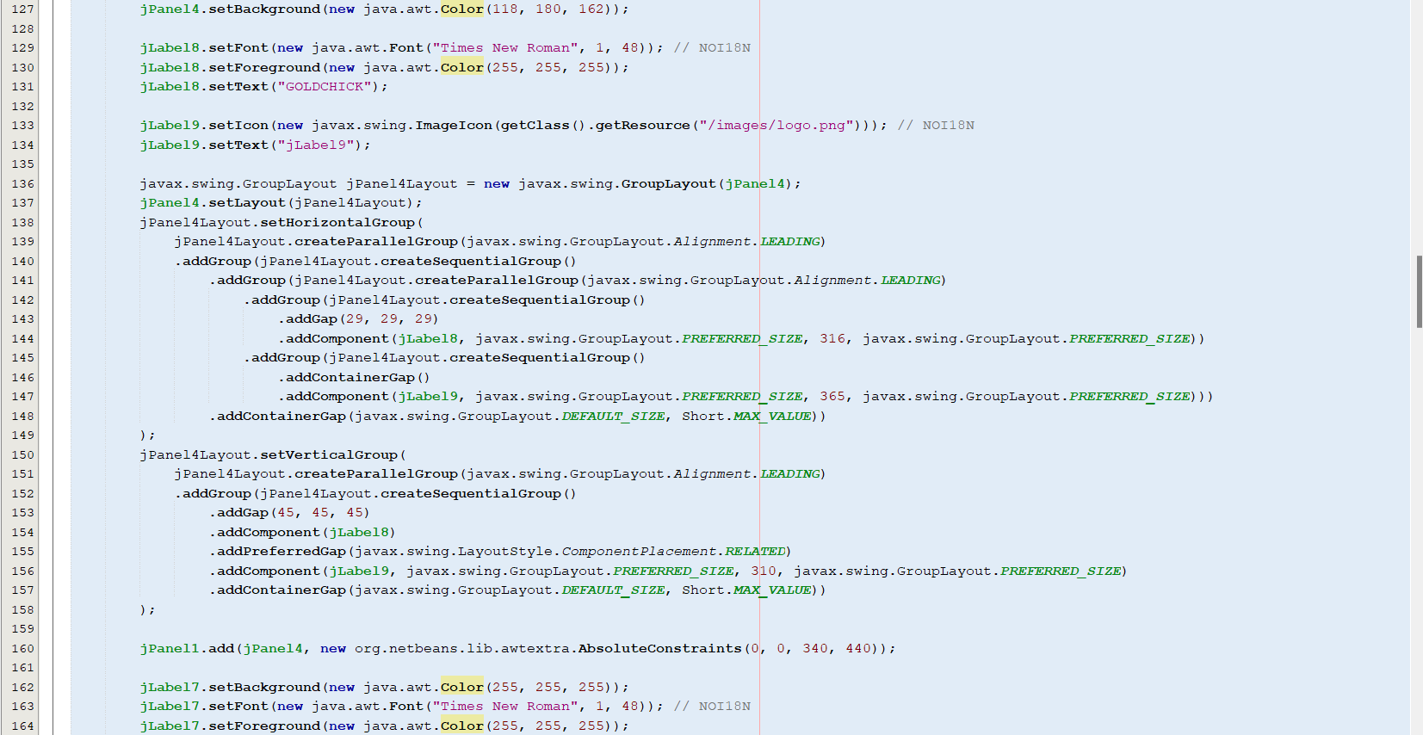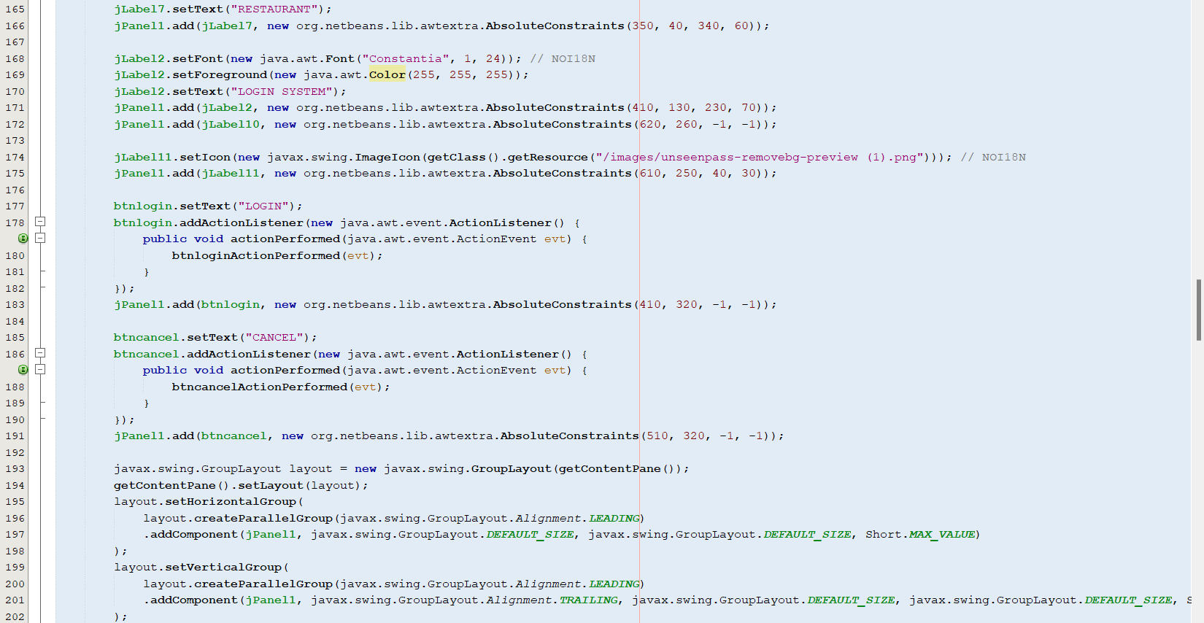

**SYSTEM PROCESS**

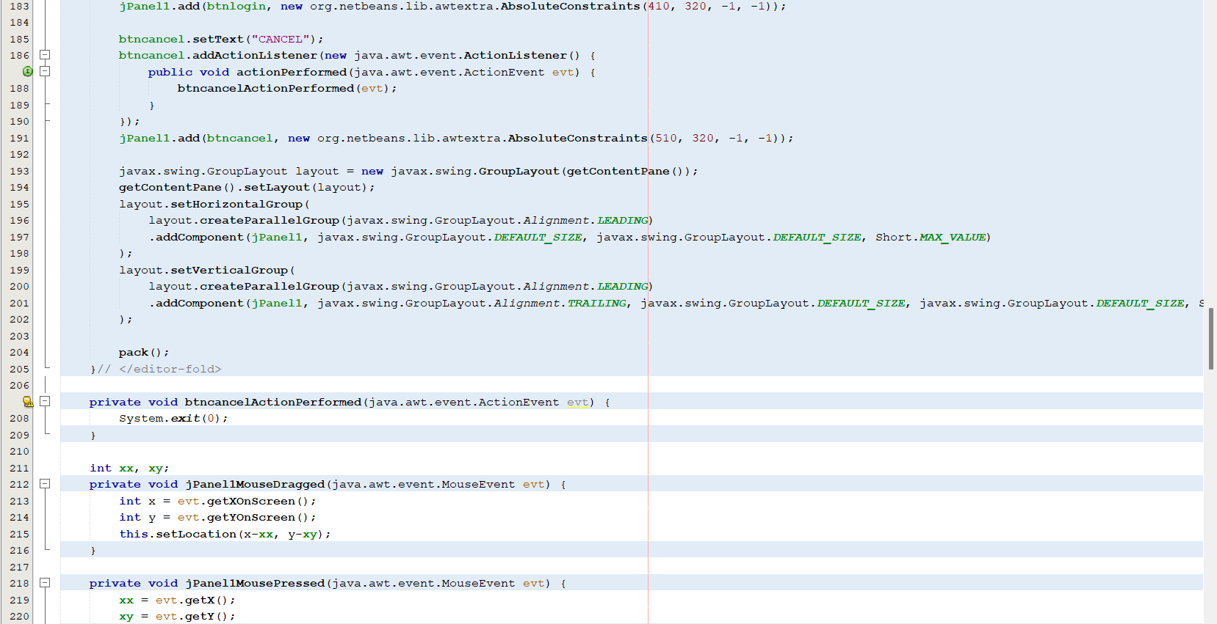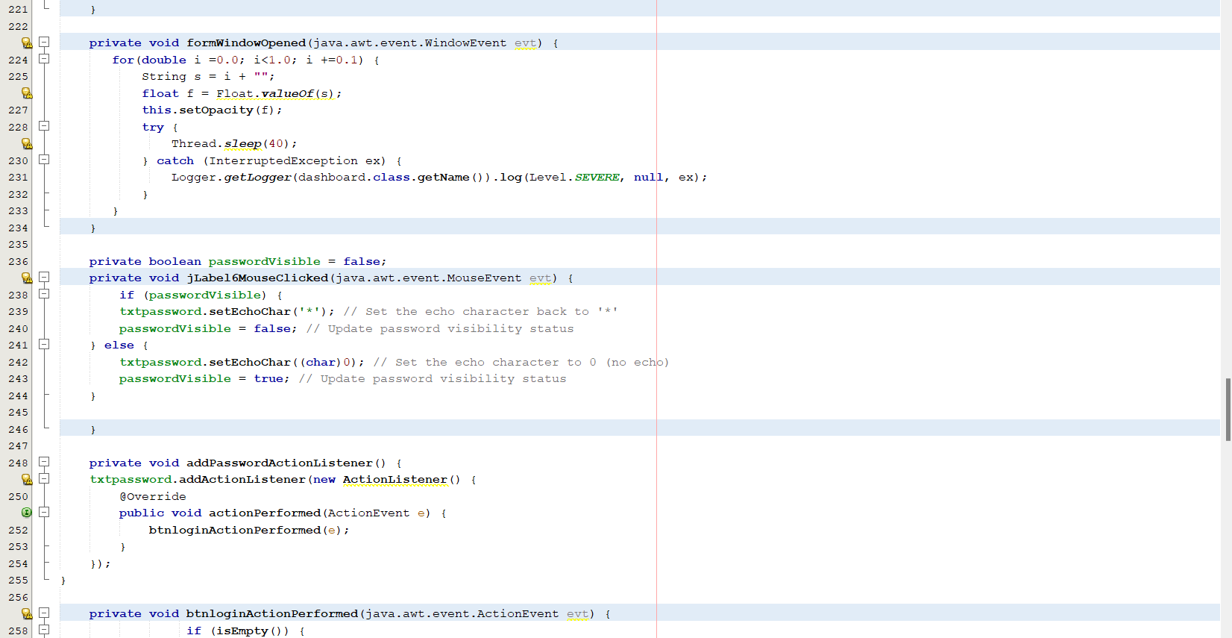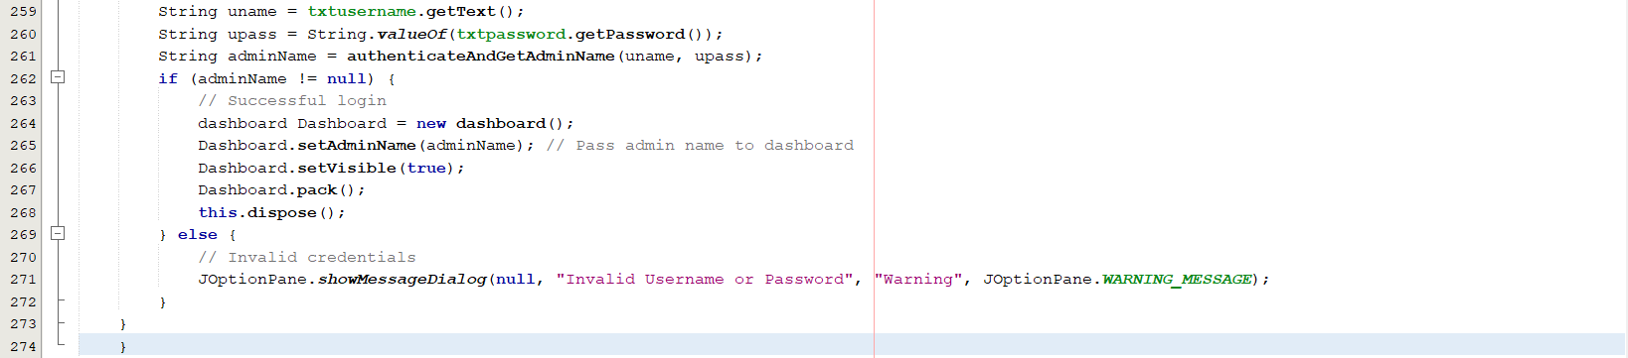

**SYSTEM PROCESS**

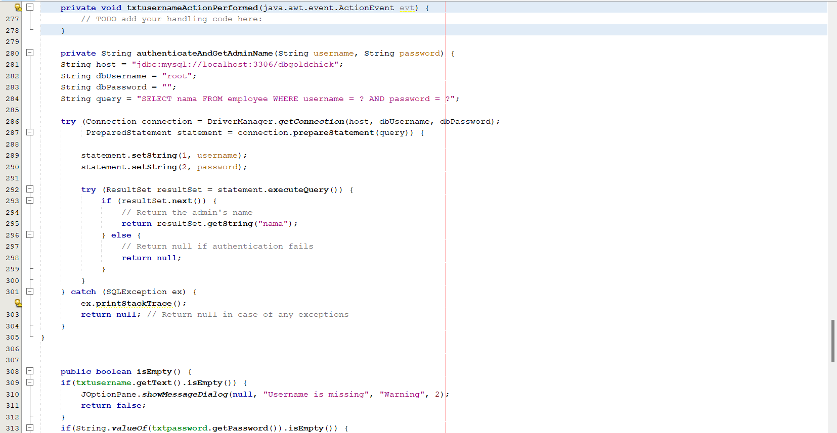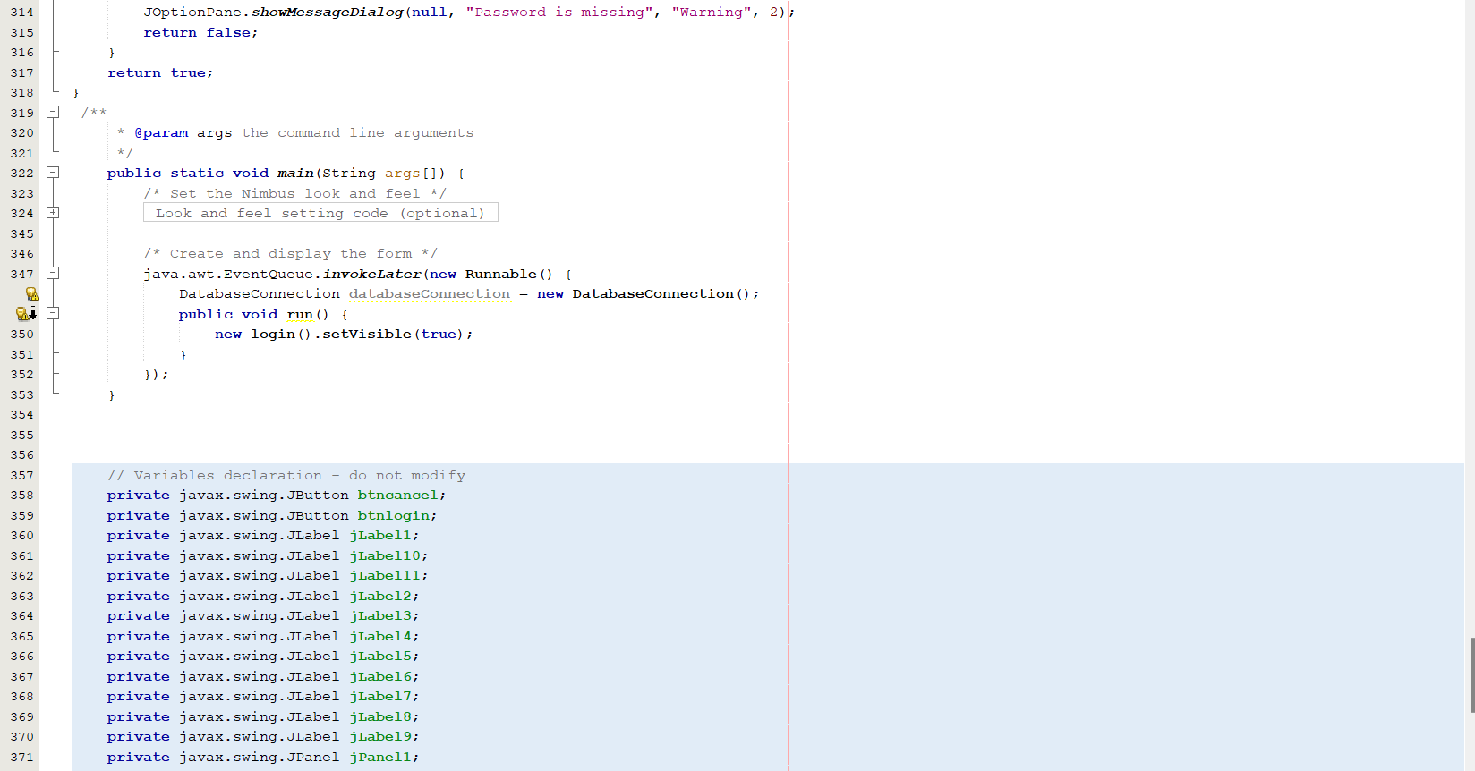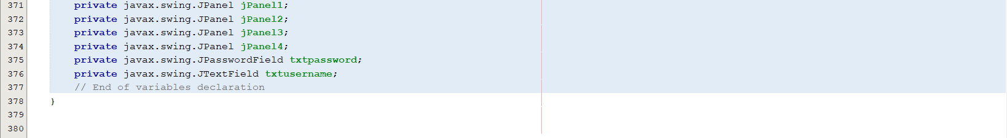

**SYSTEM PROCESS**

1. **Dashboard**

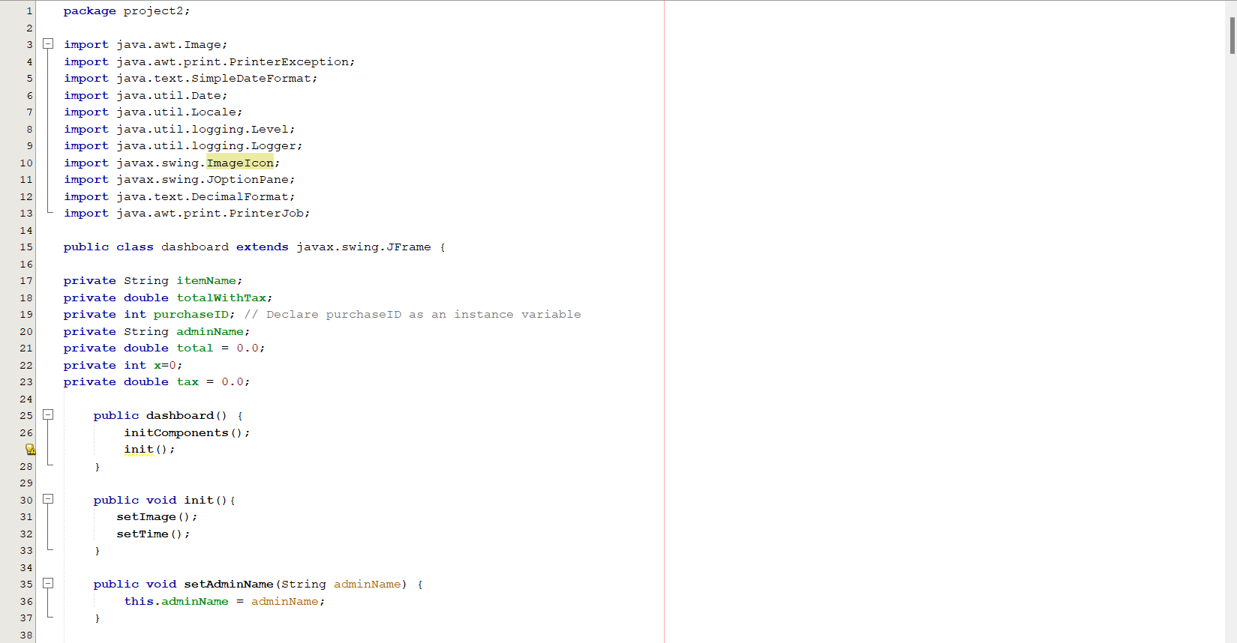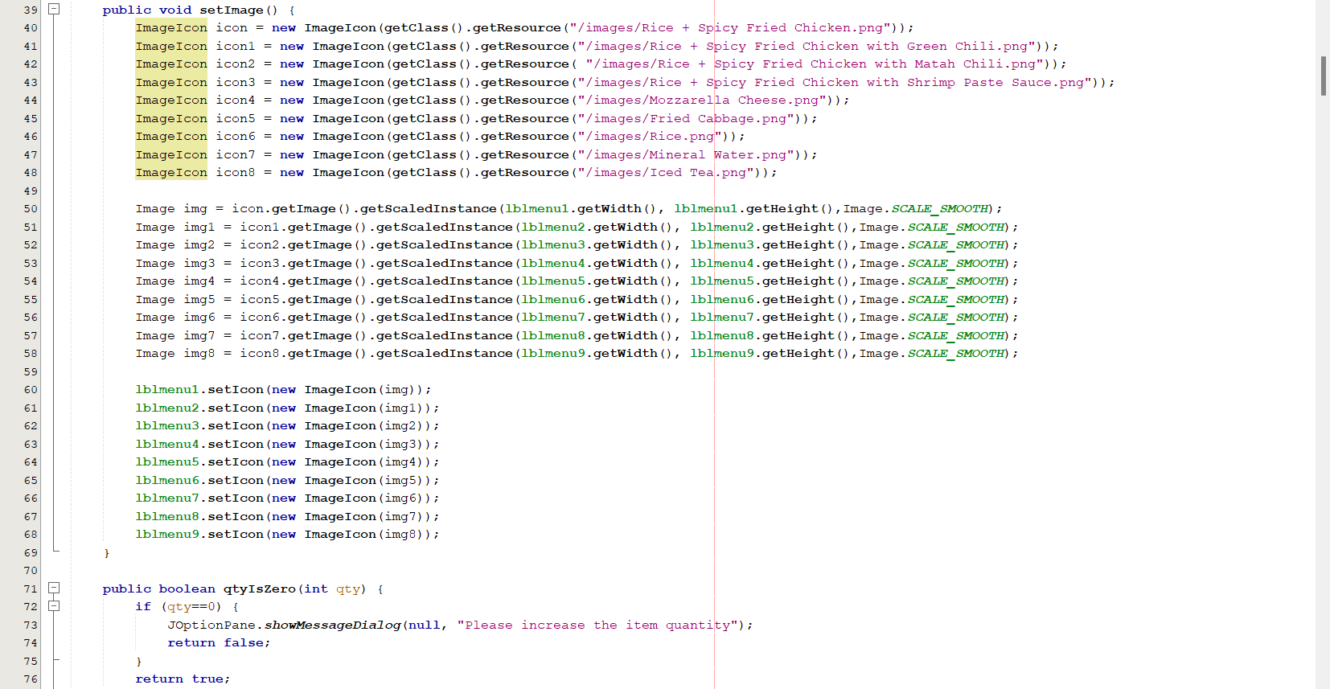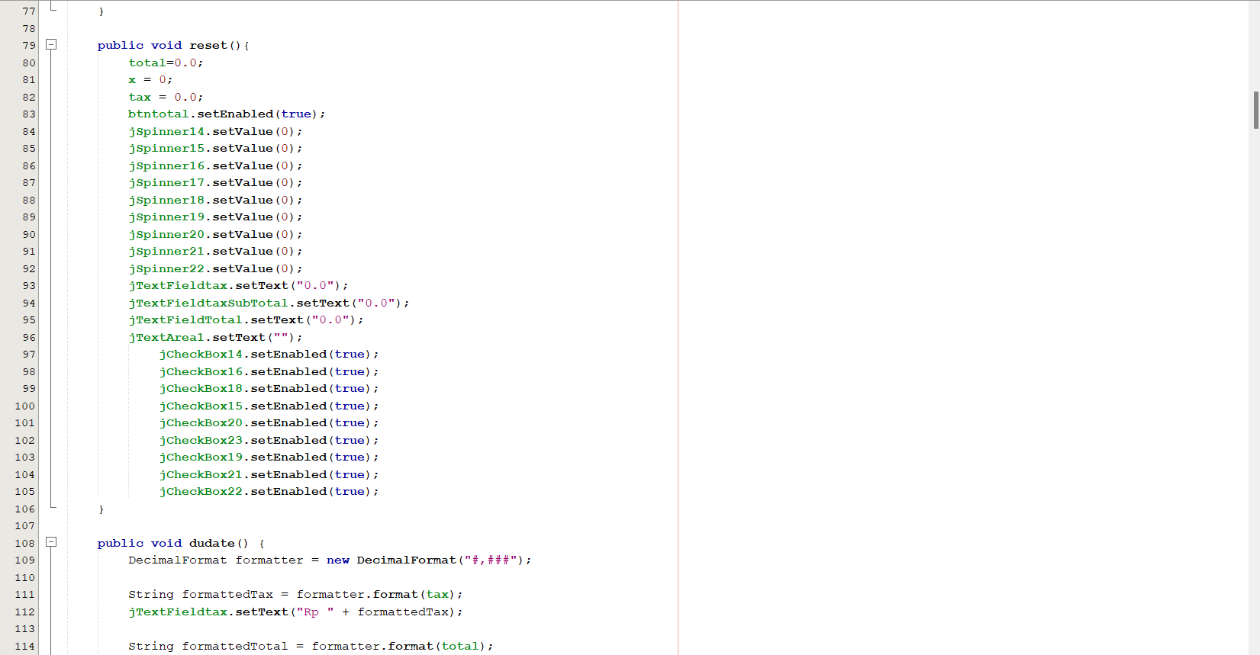

**SYSTEM PROCESS**

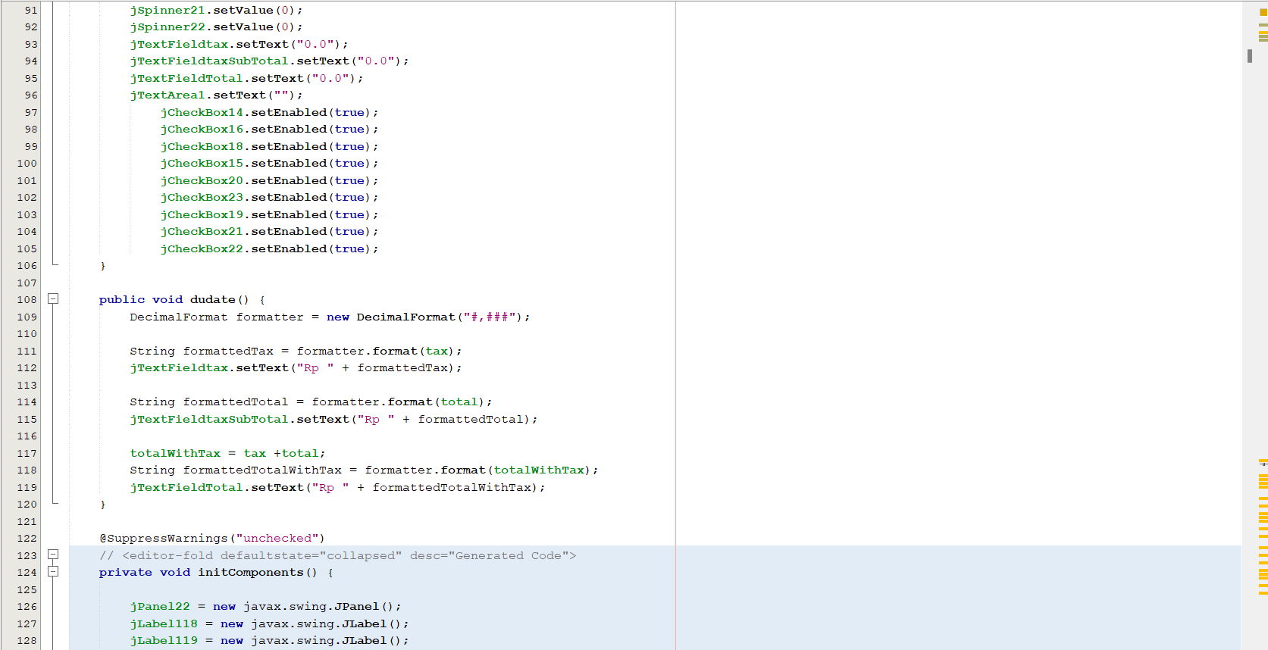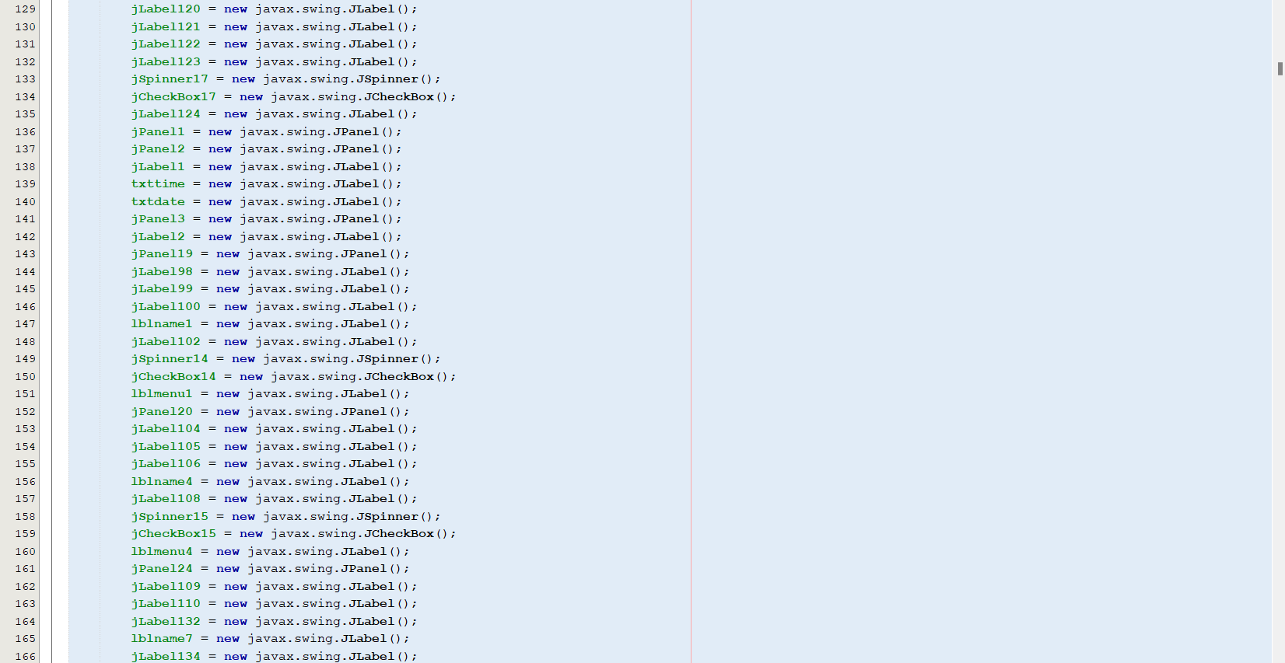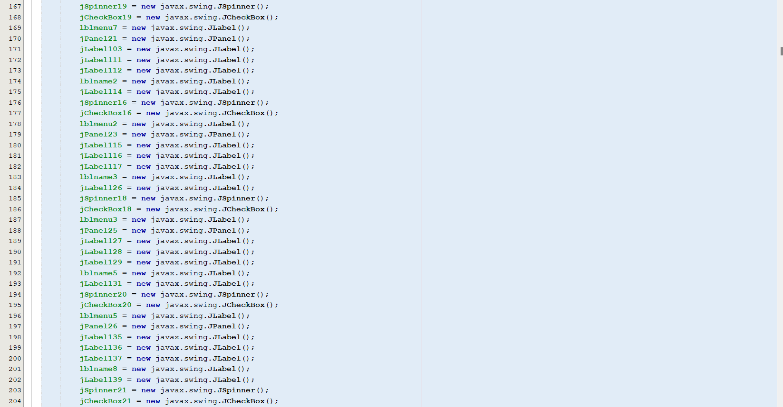

**SYSTEM PROCESS**

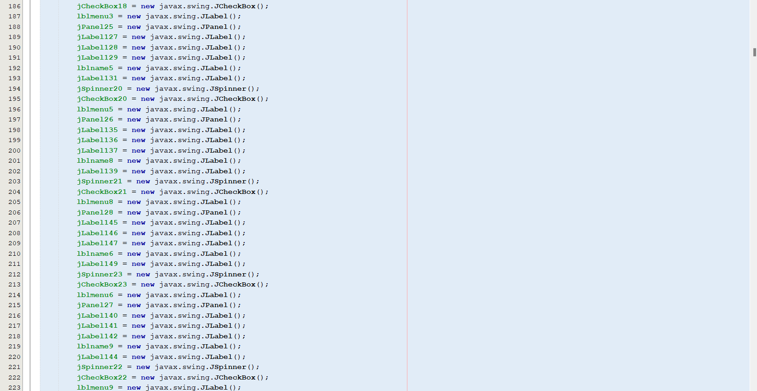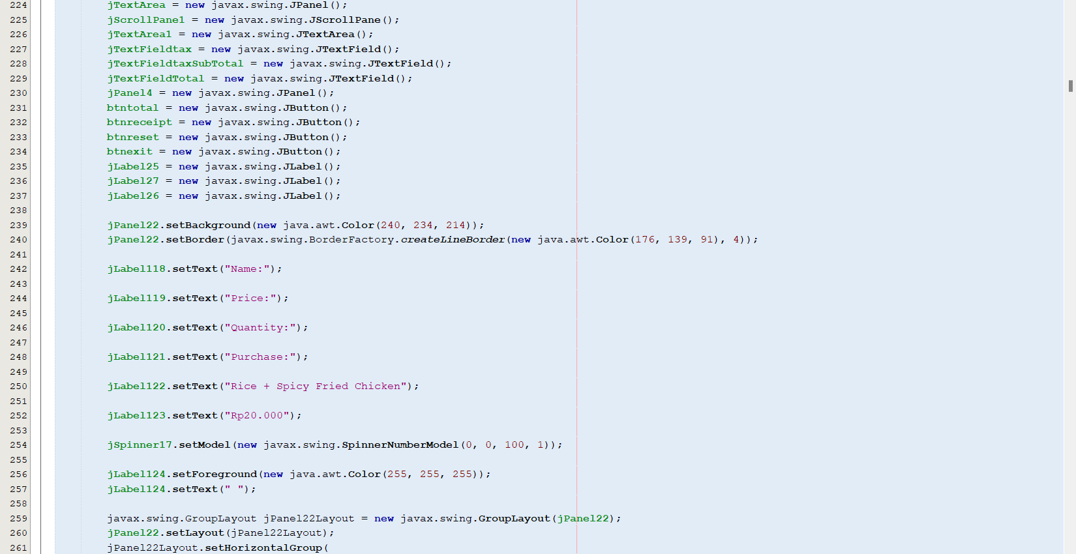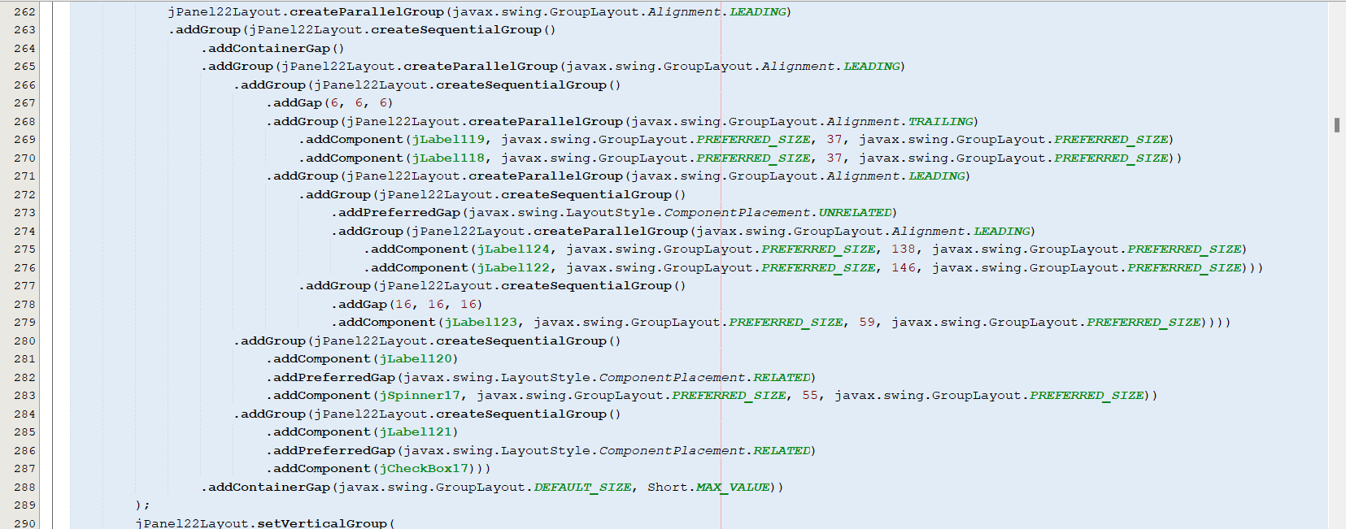

**SYSTEM PROCESS**

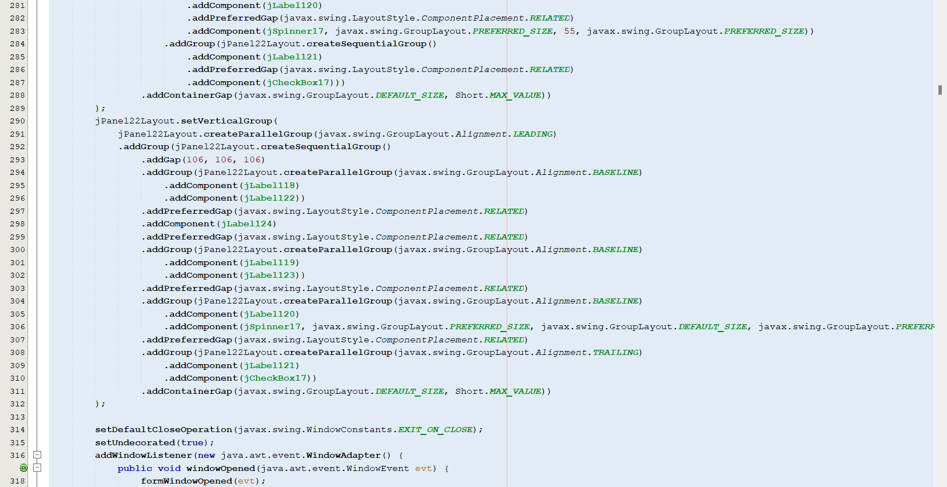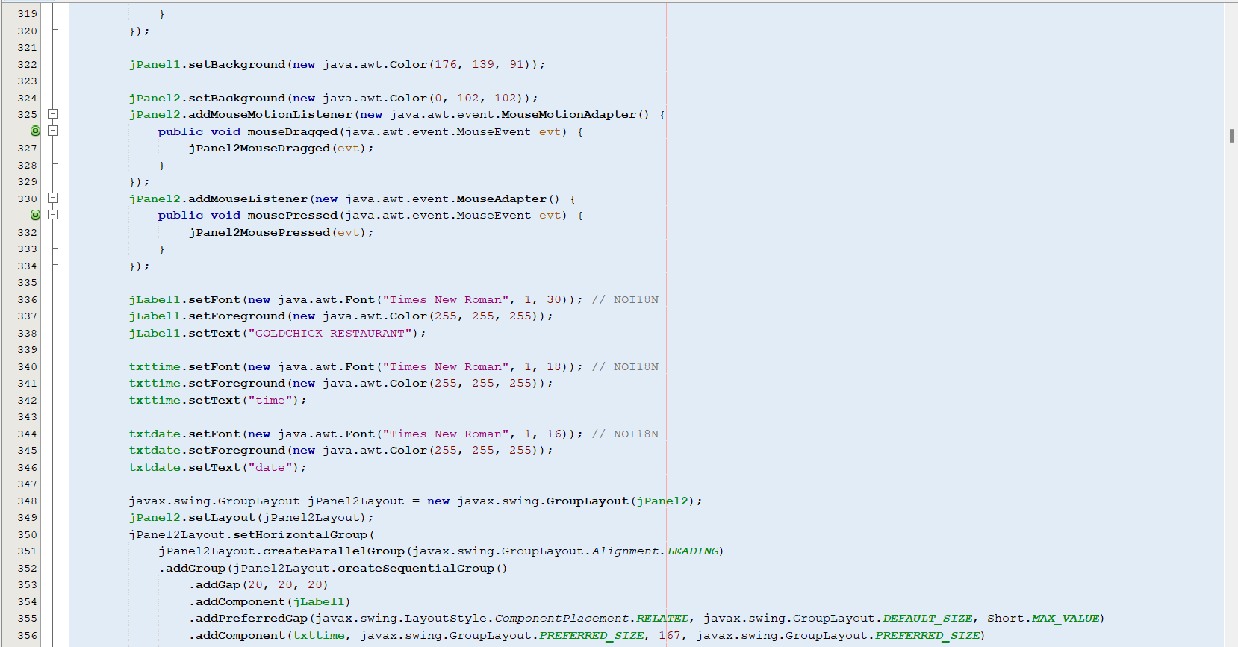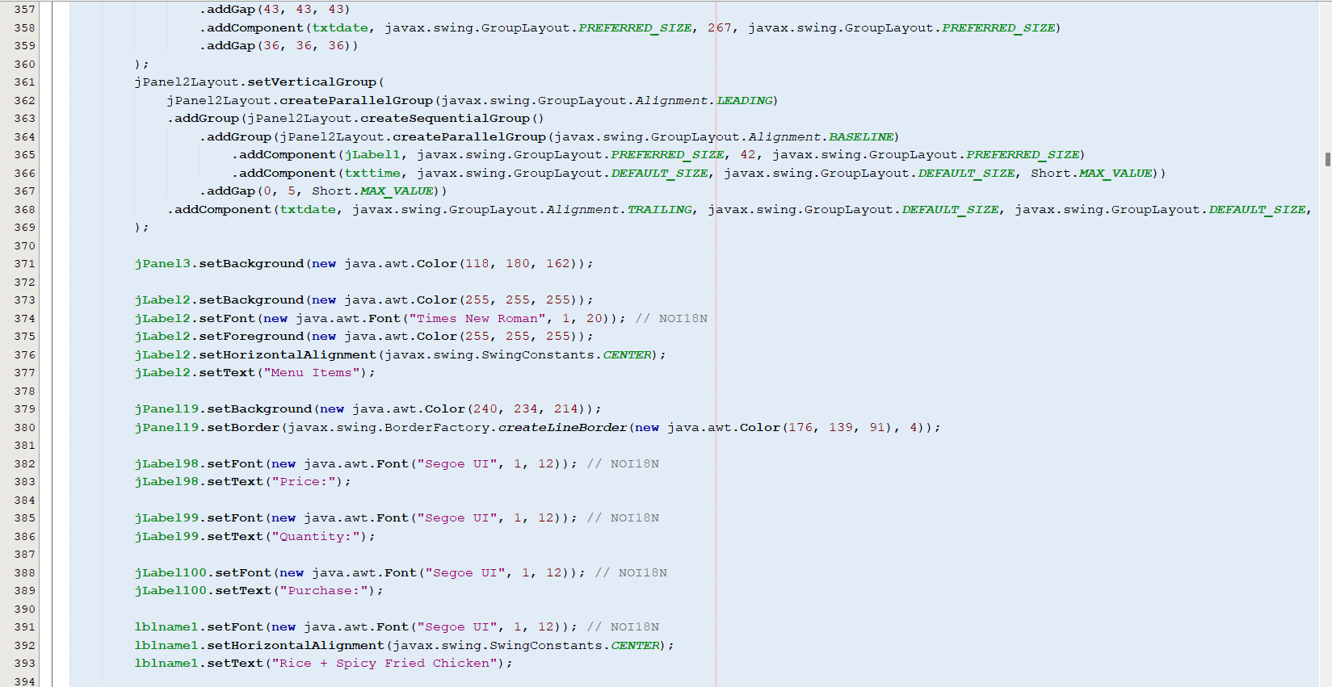

**SYSTEM PROCESS**

**SYSTEM PROCESS**

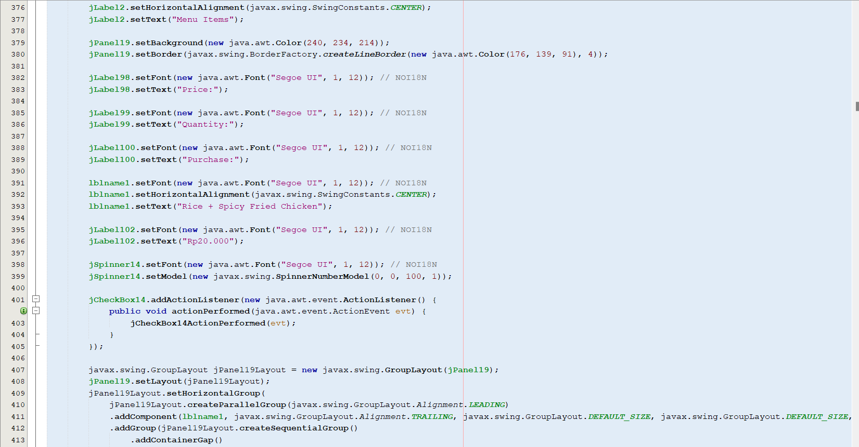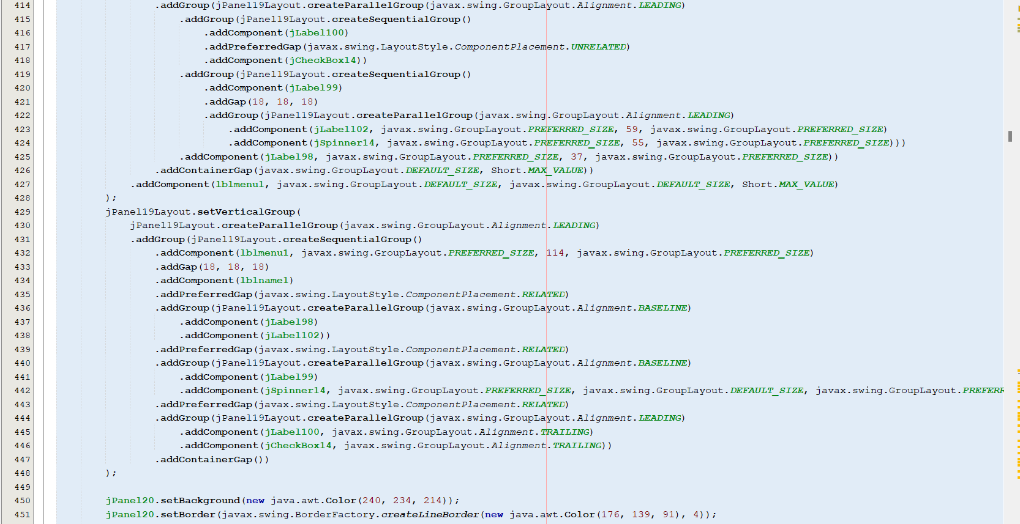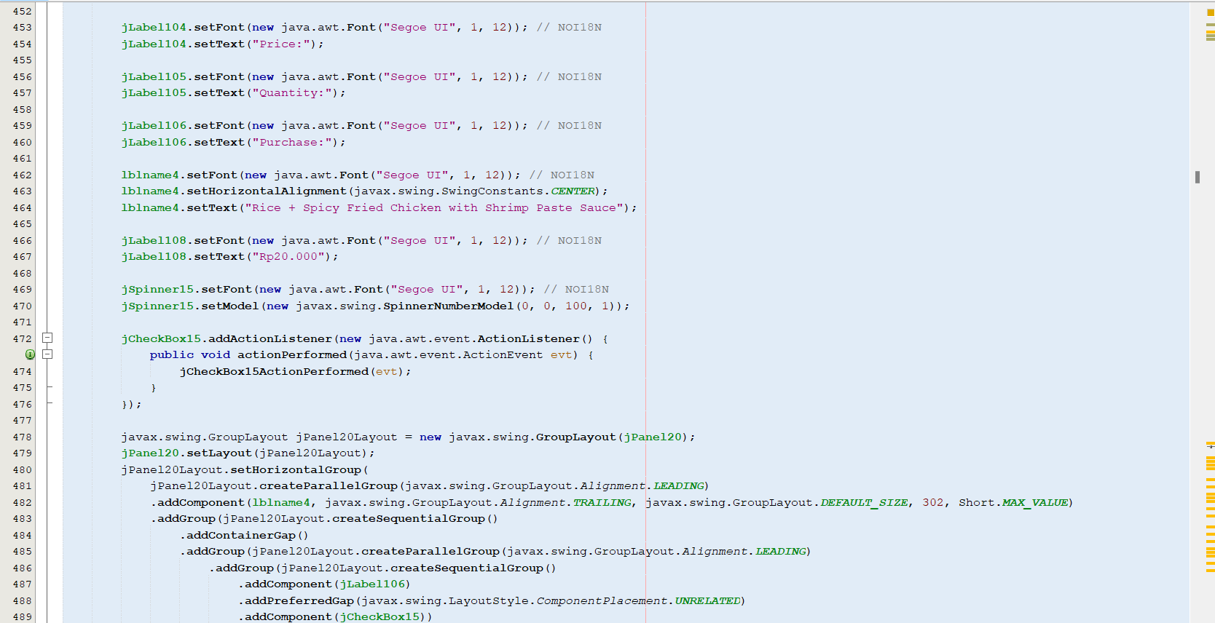

**SYSTEM PROCESS**

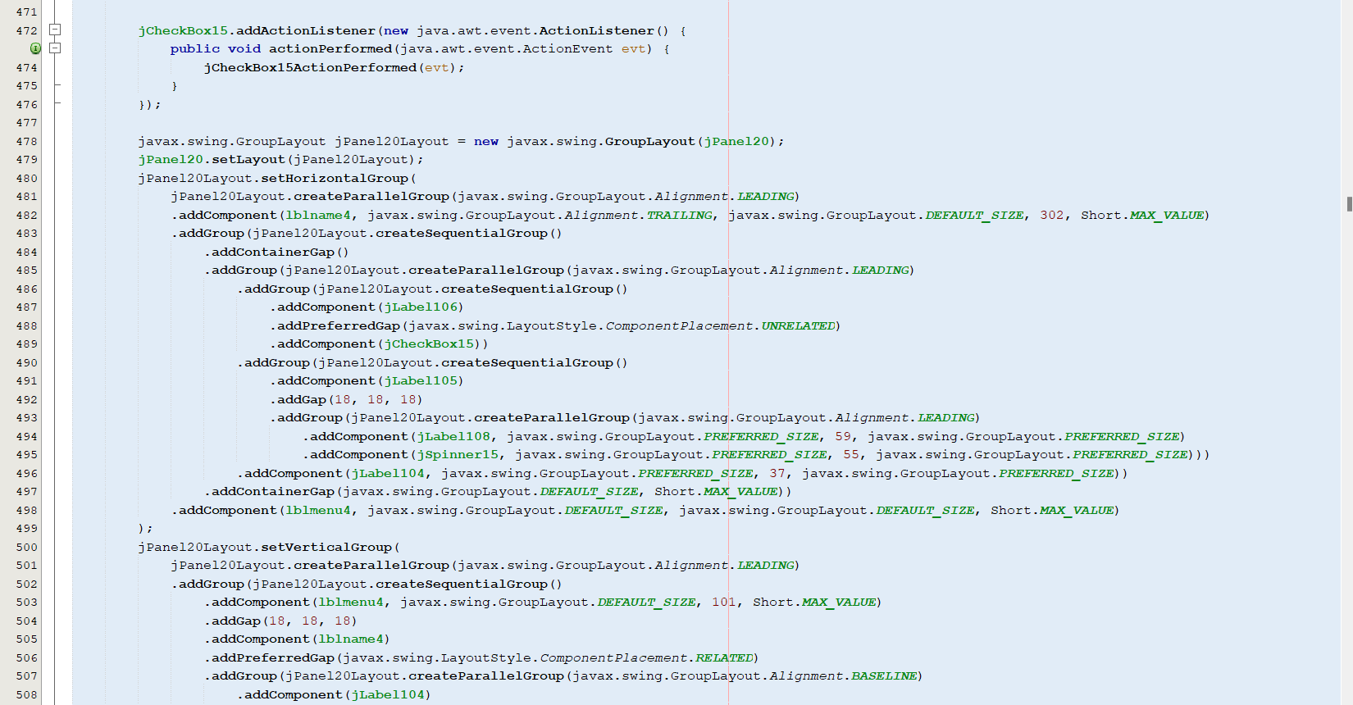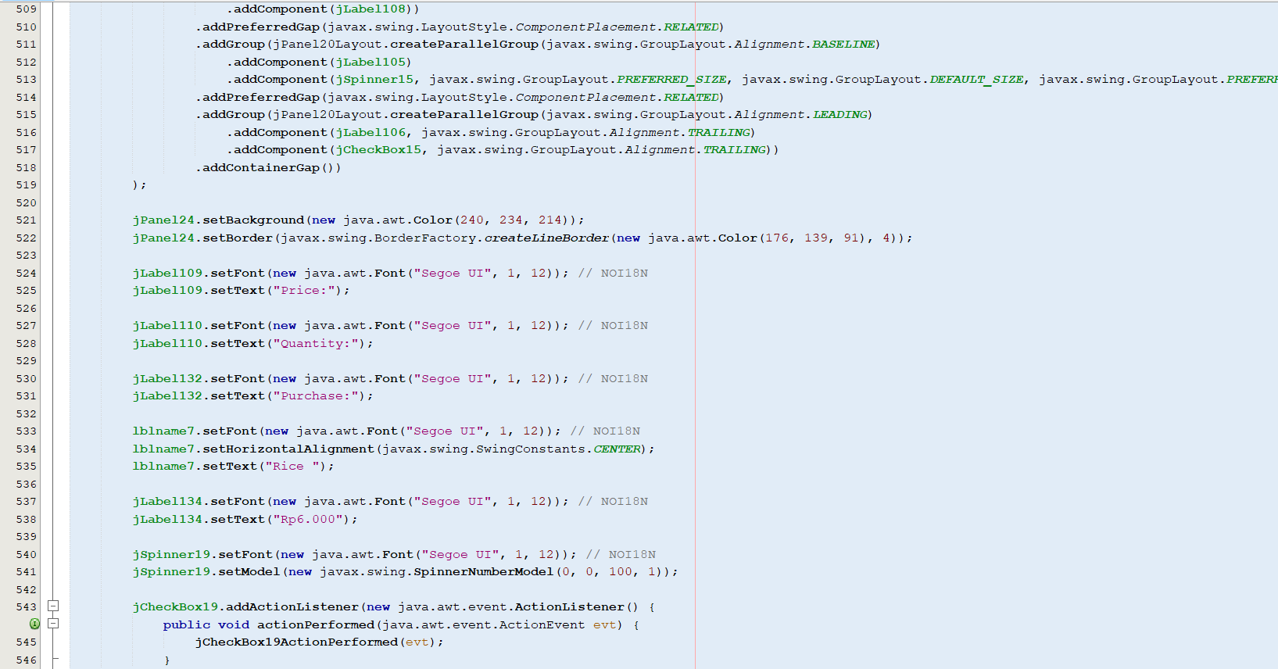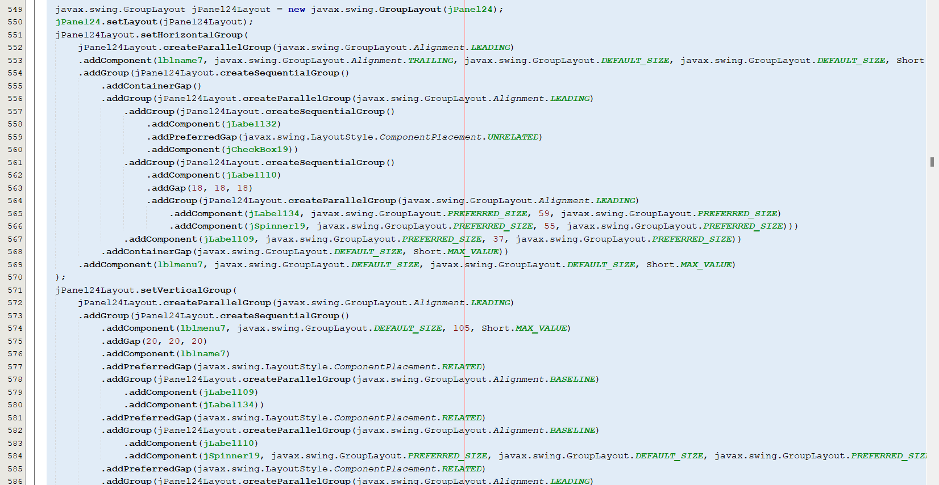

**SYSTEM PROCESS**

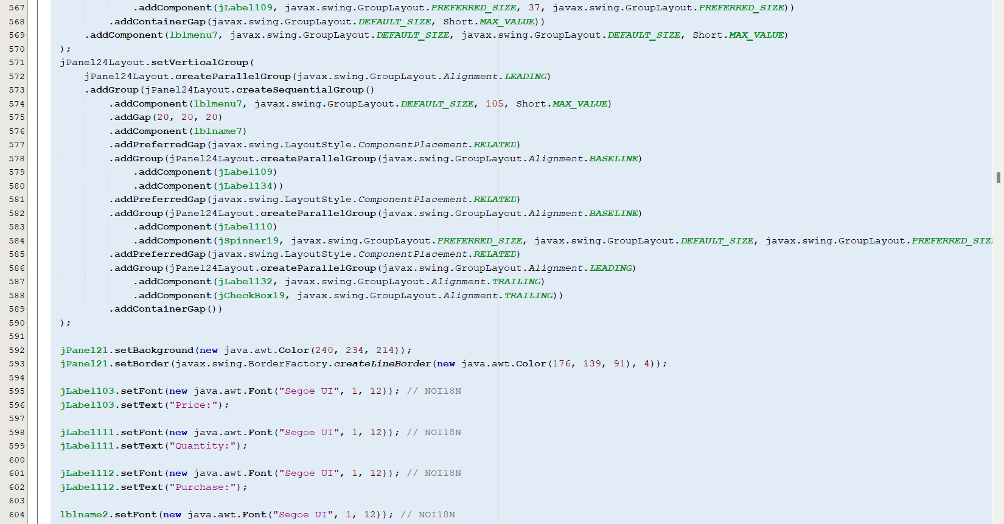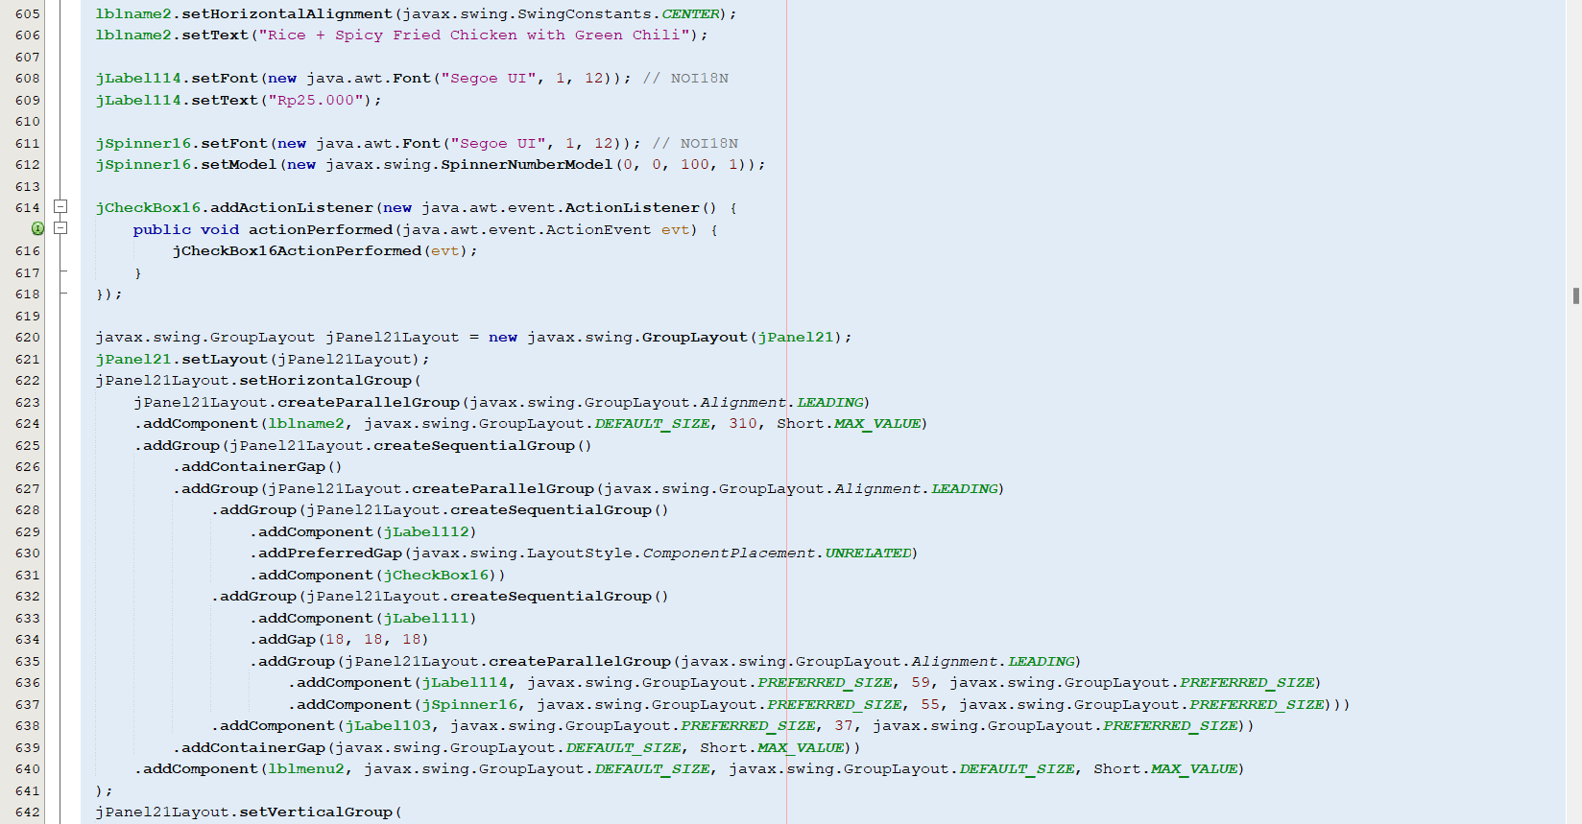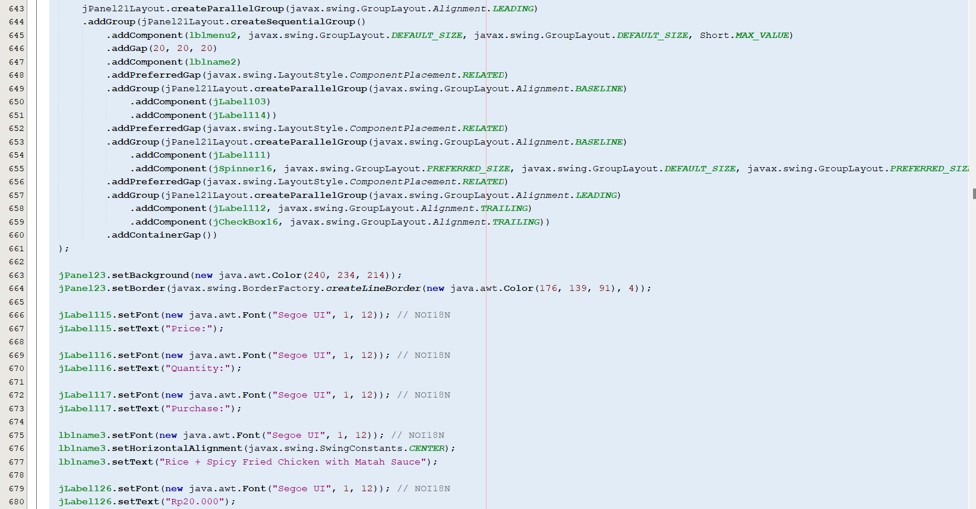

**SYSTEM PROCESS**

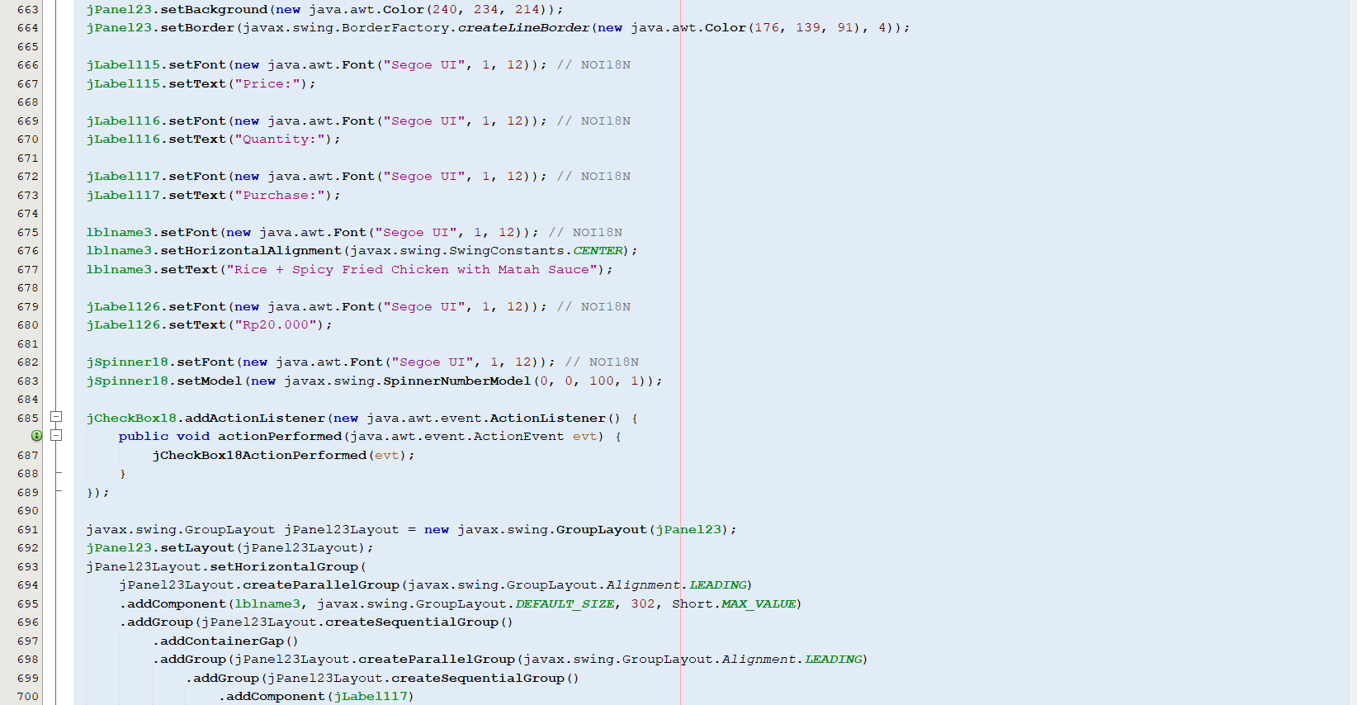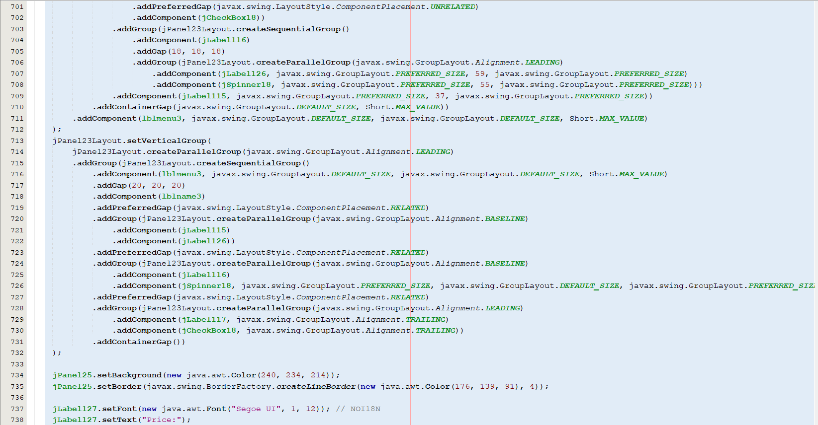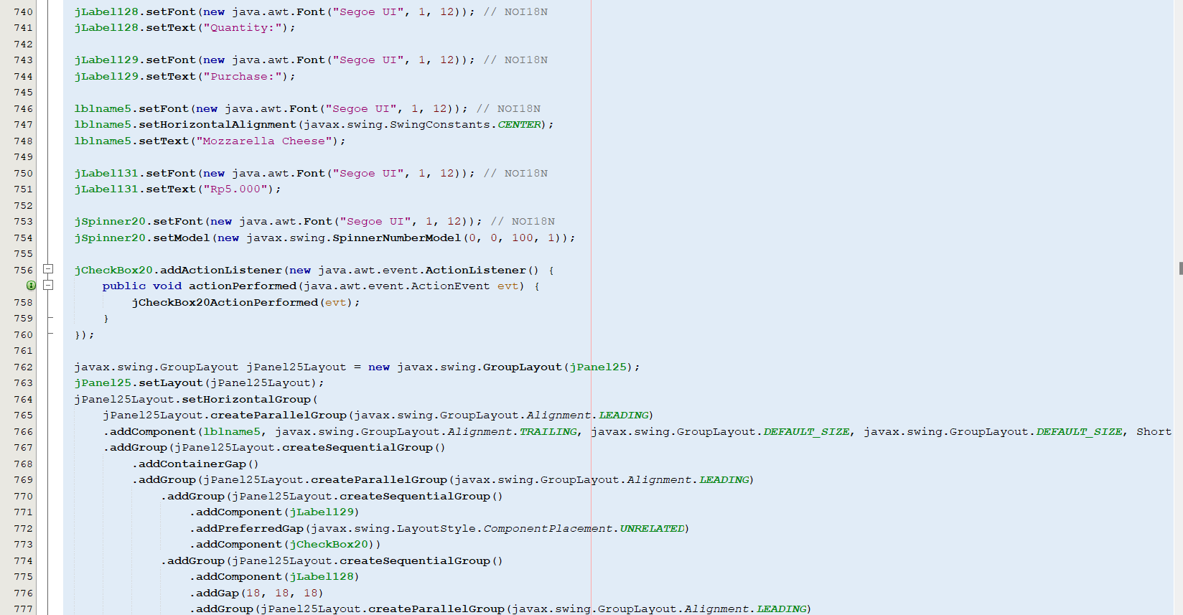

**SYSTEM PROCESS**

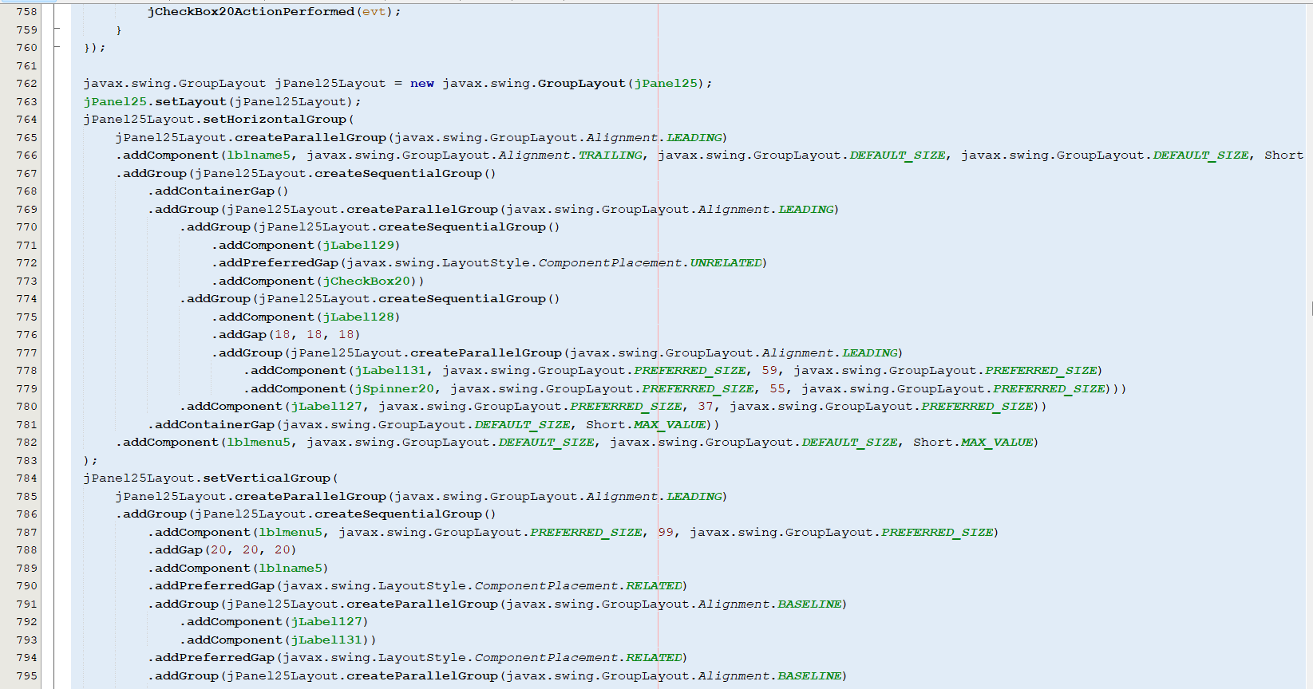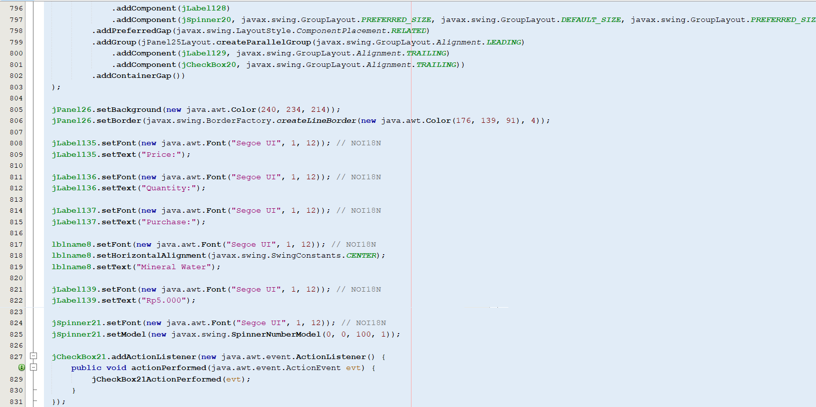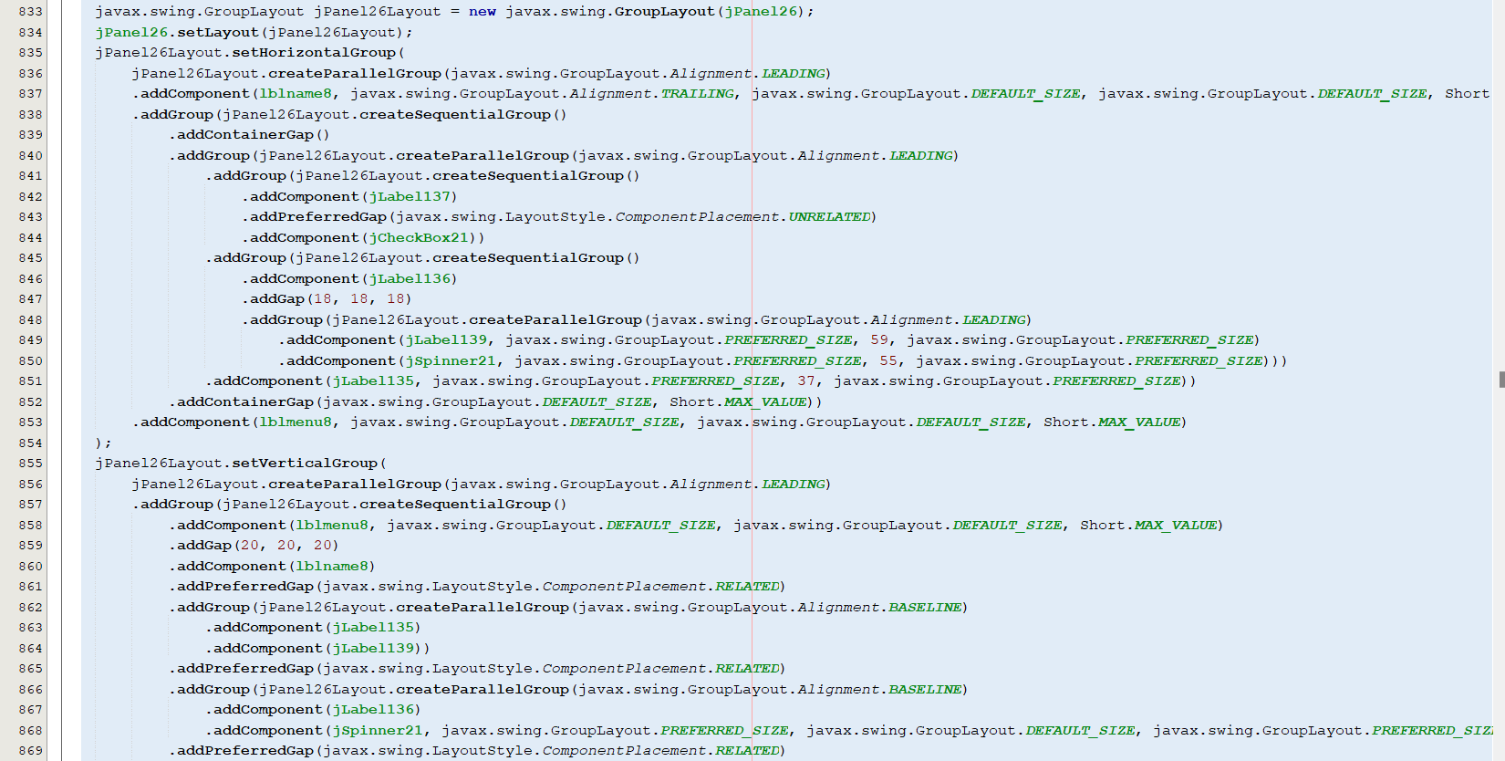

**SYSTEM PROCESS**

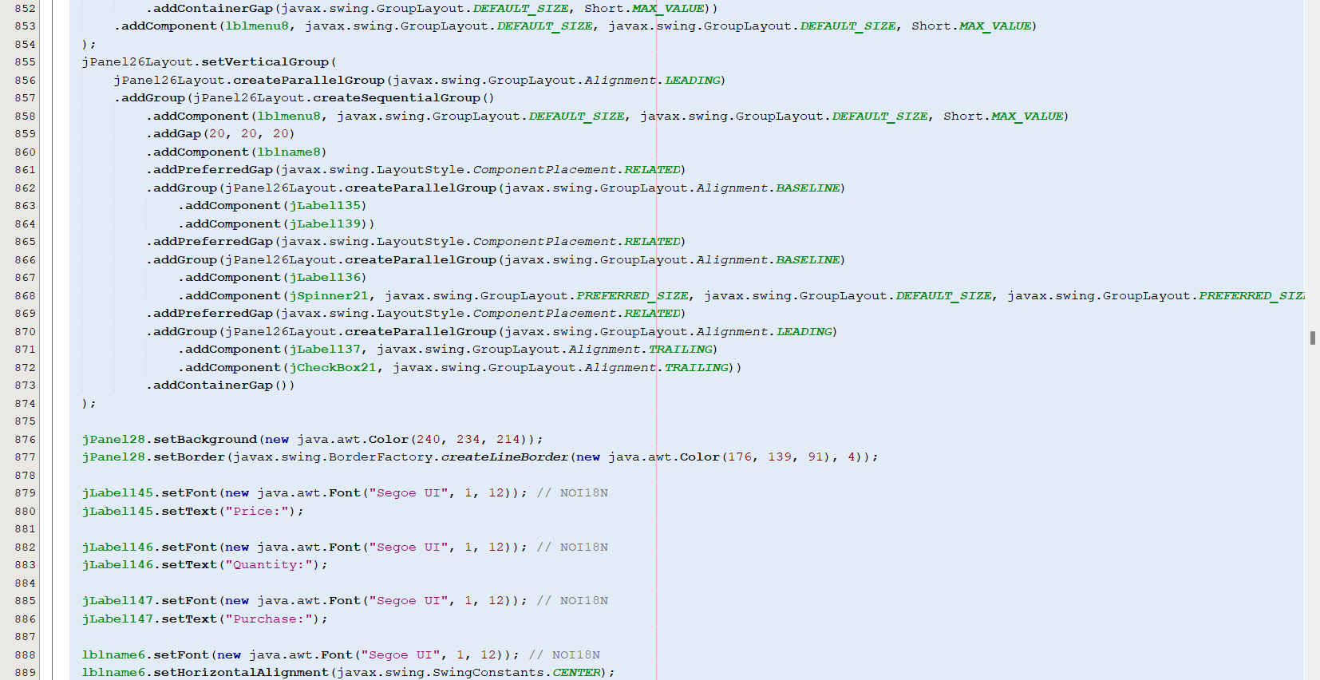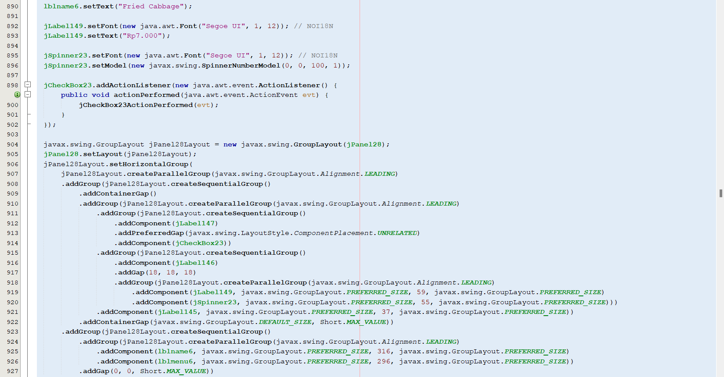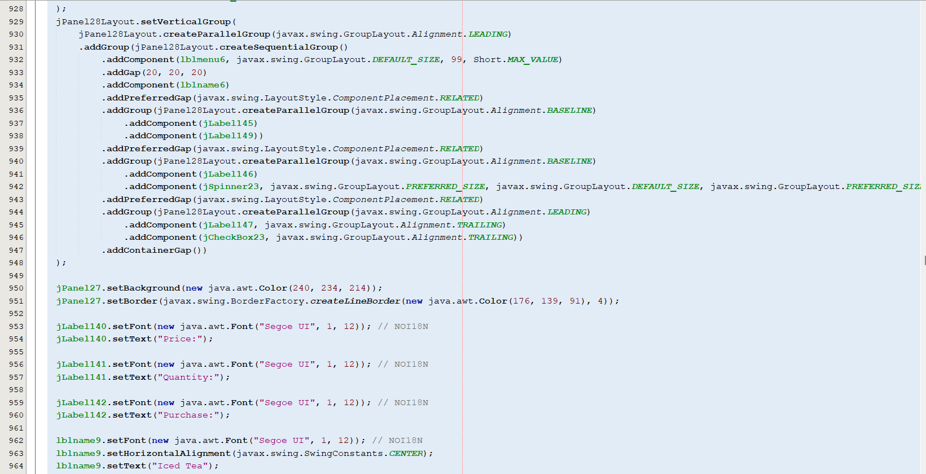

**SYSTEM PROCESS**

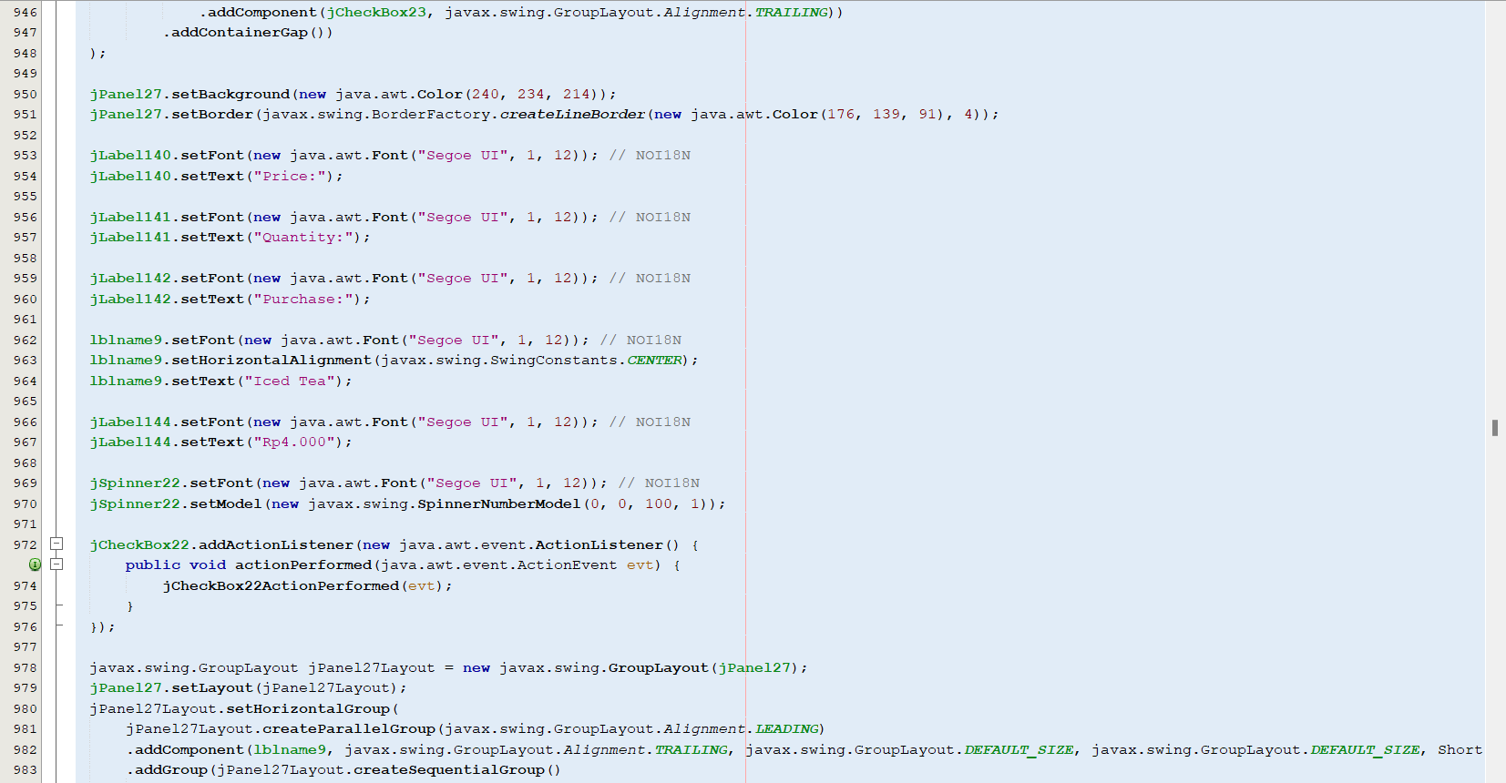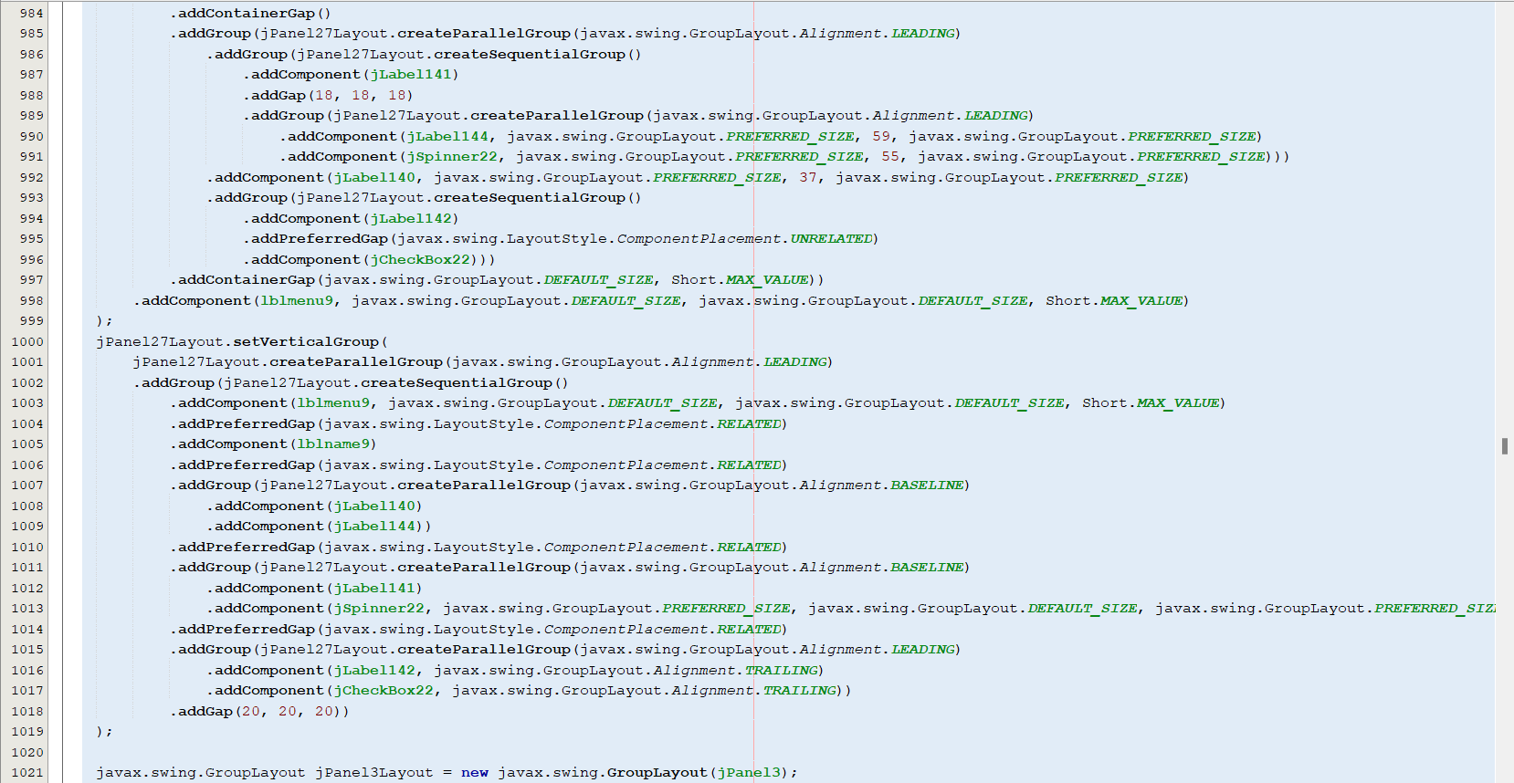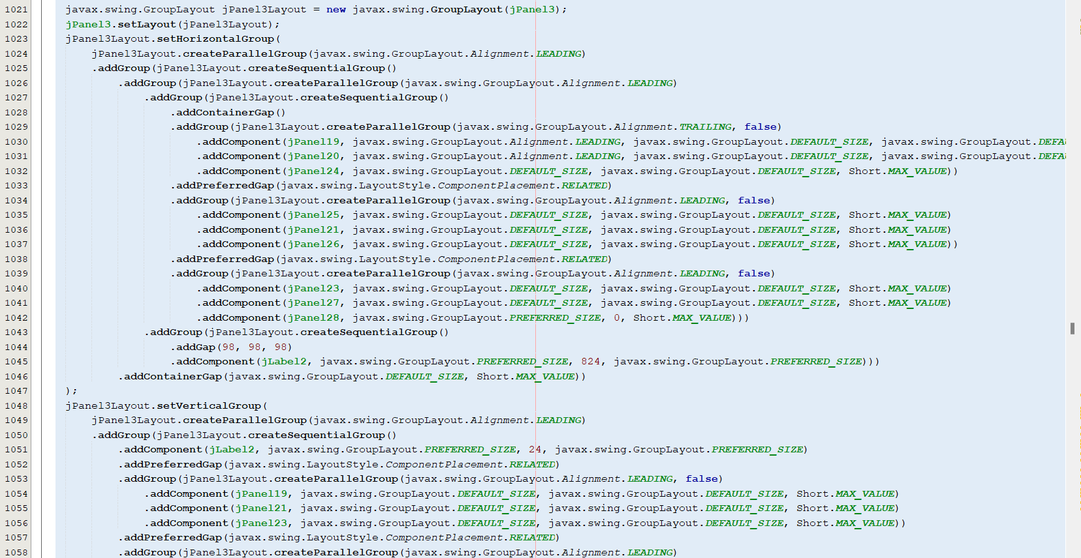

**SYSTEM PROCESS**

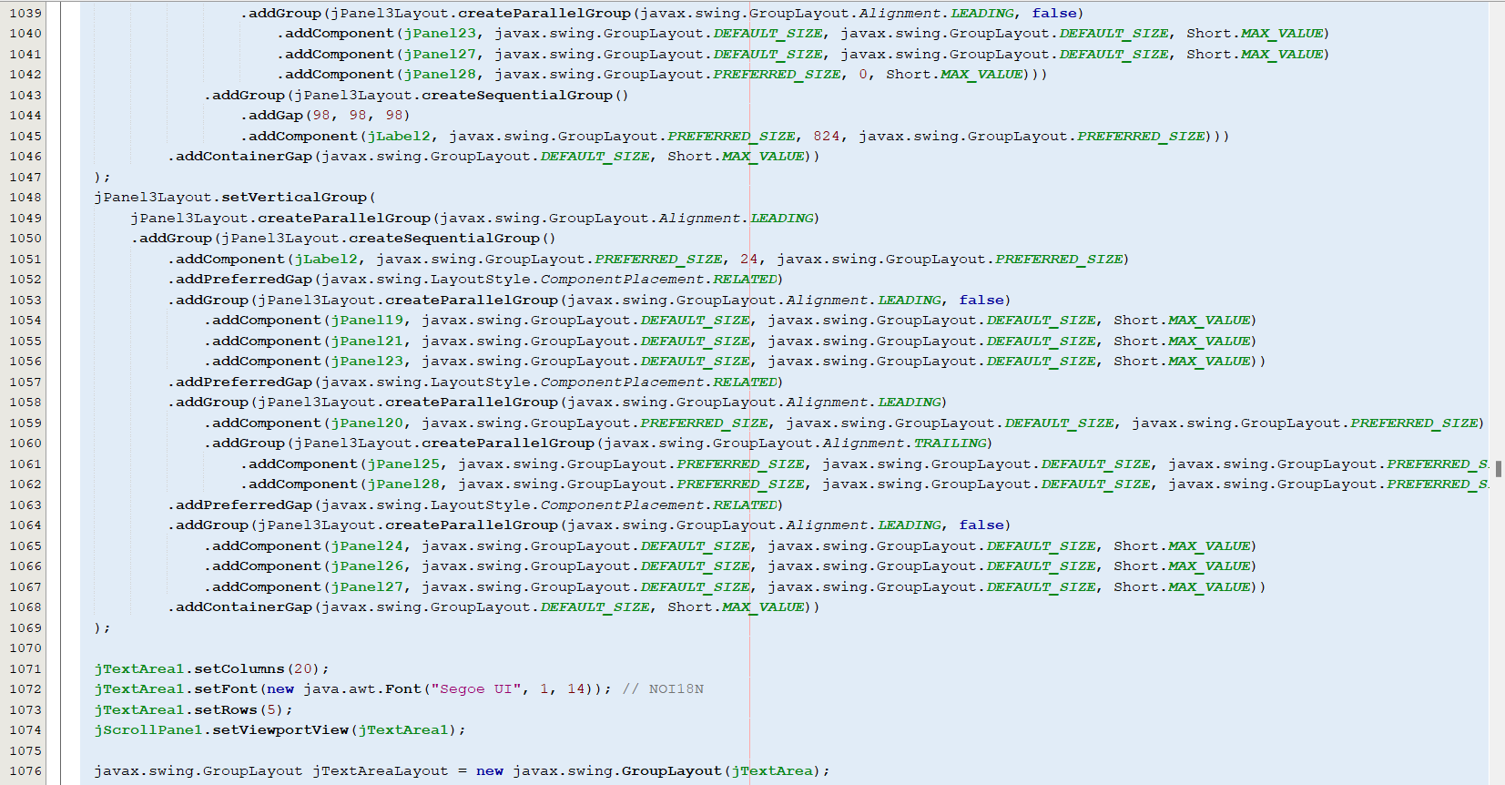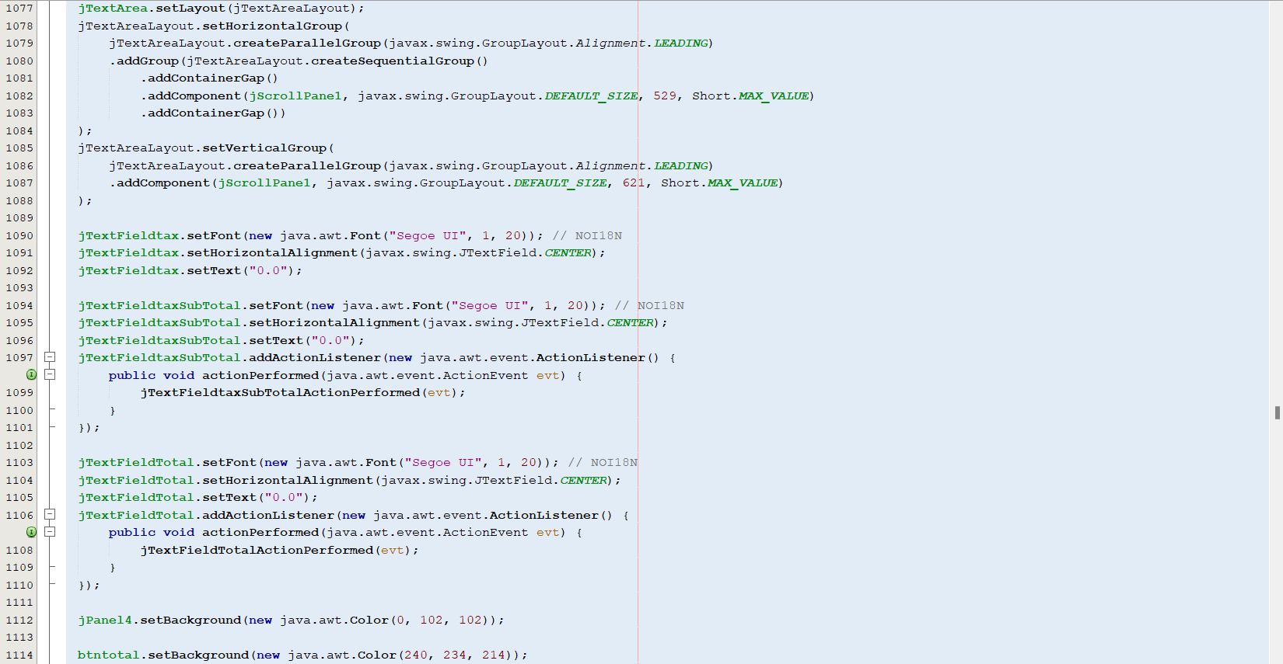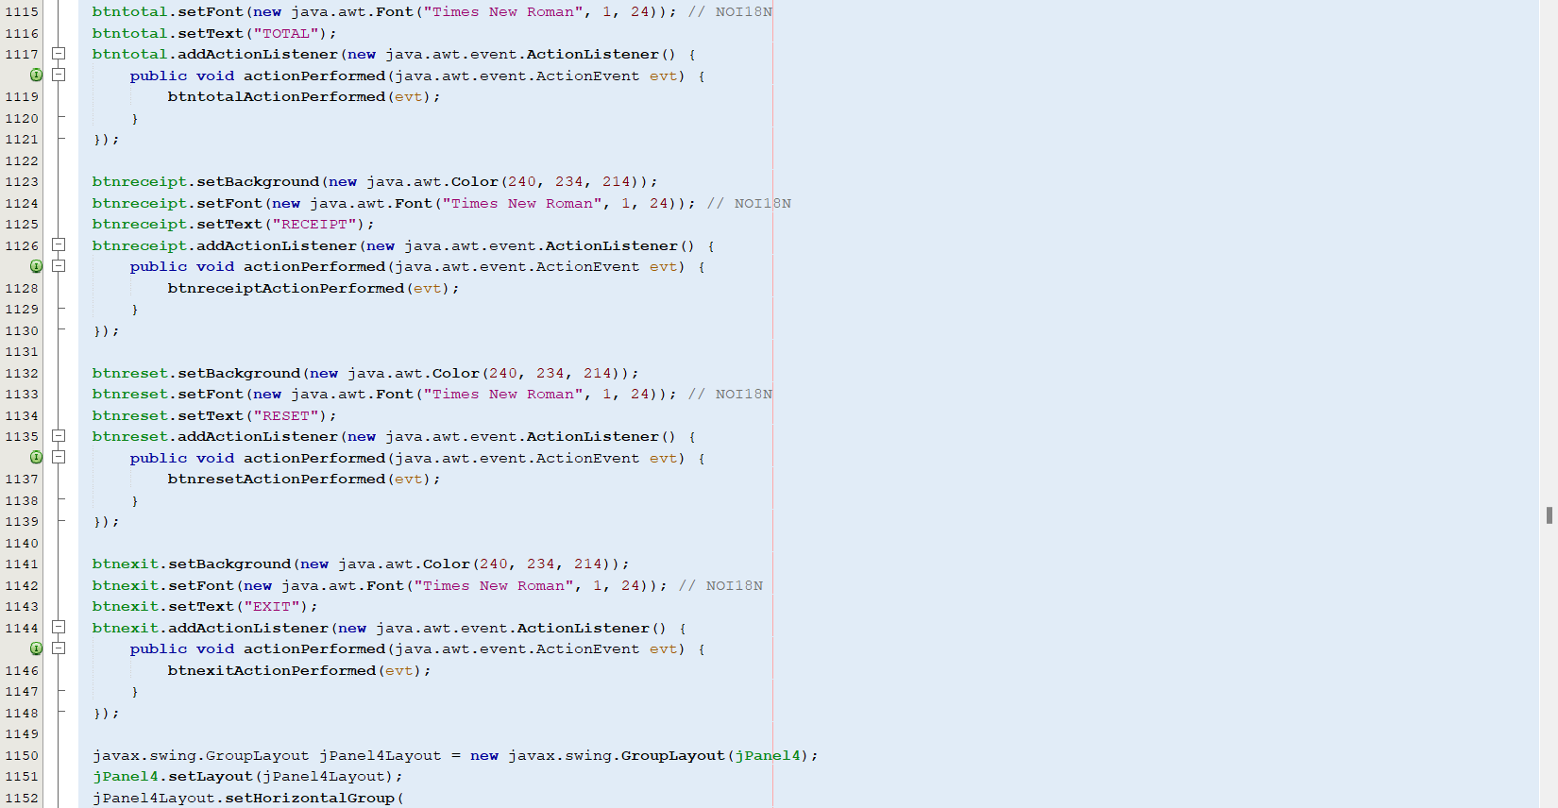

**SYSTEM PROCESS**

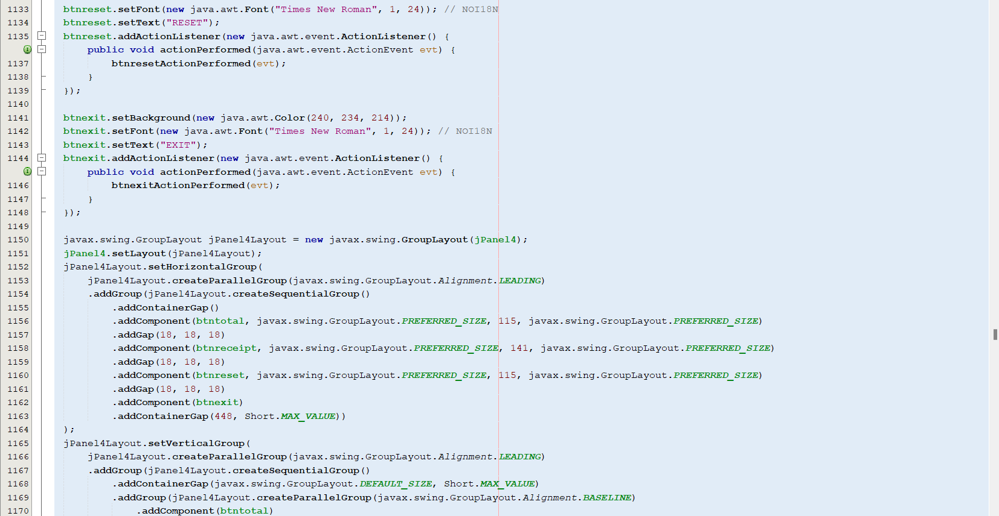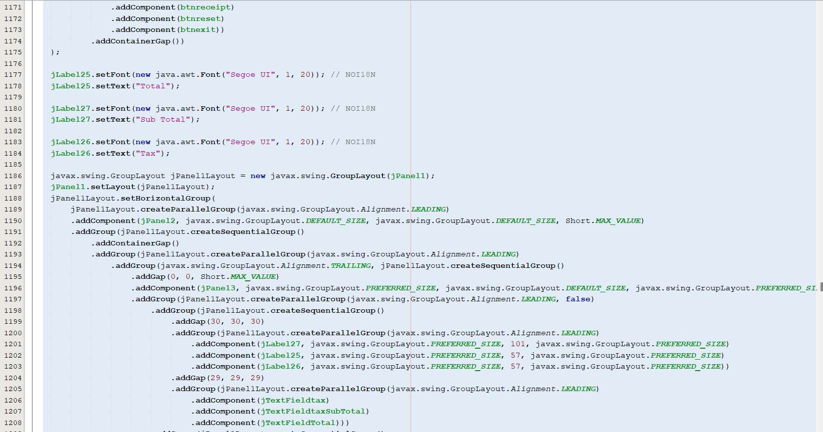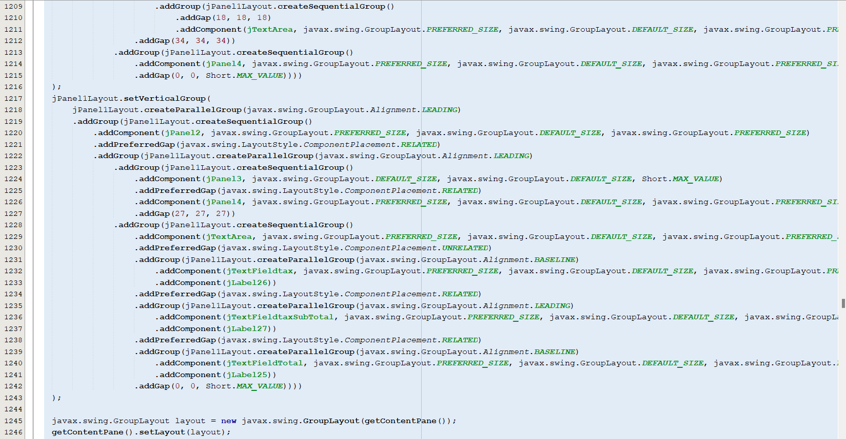

**SYSTEM PROCESS**

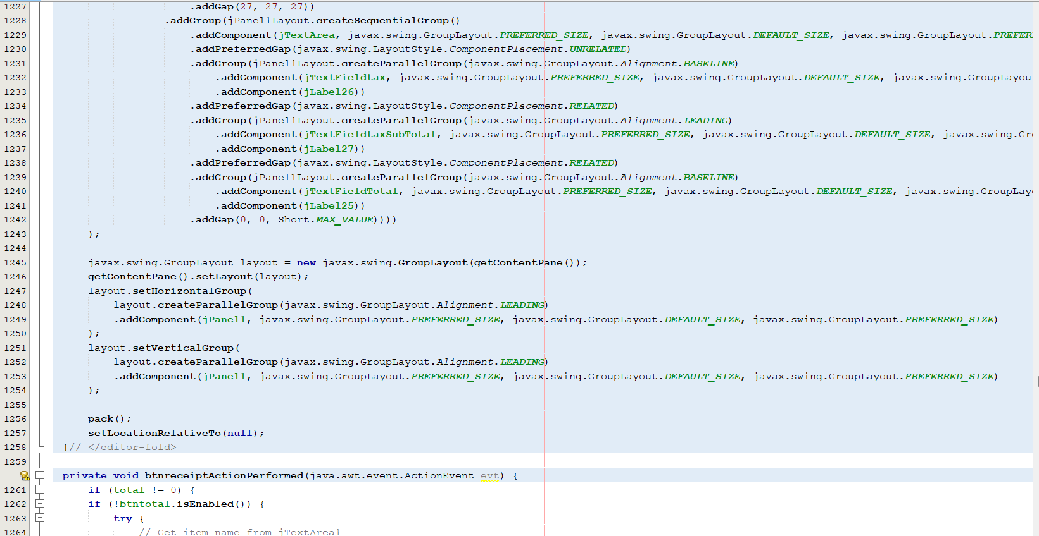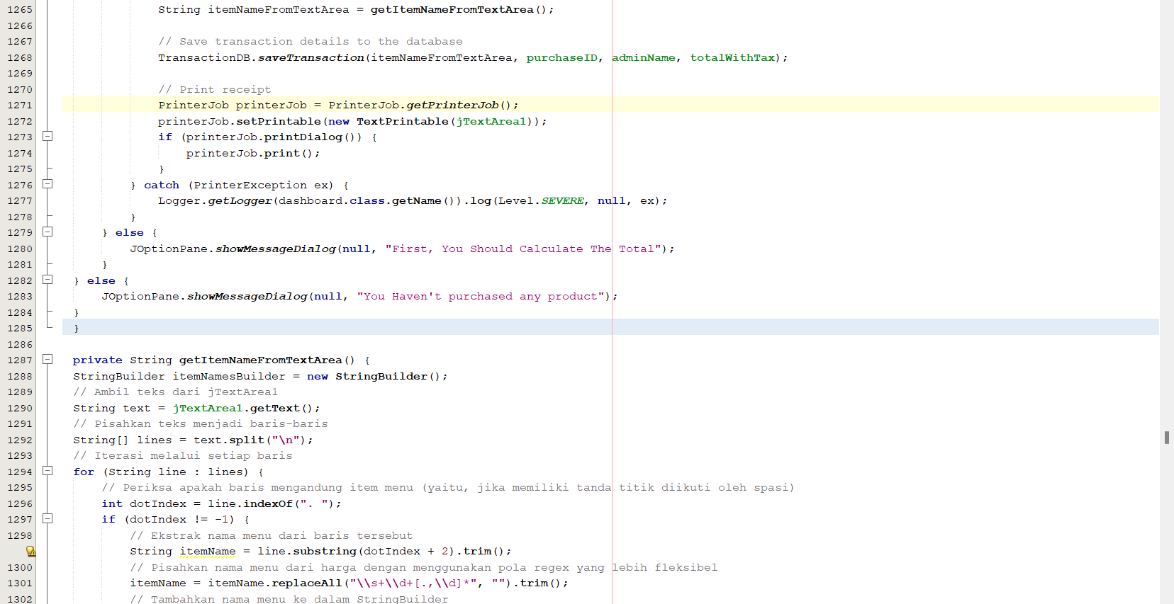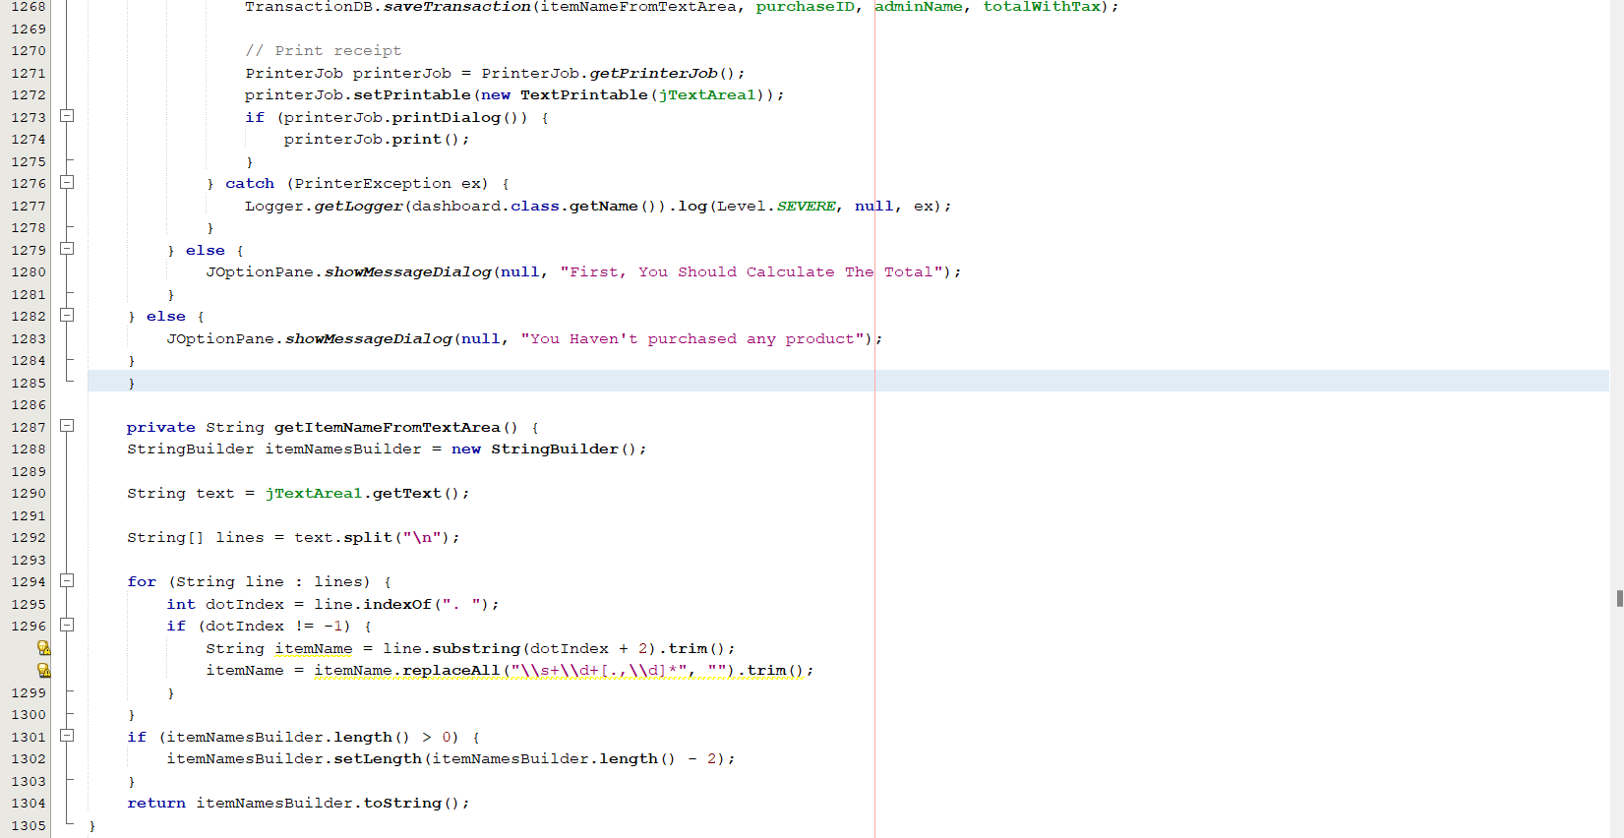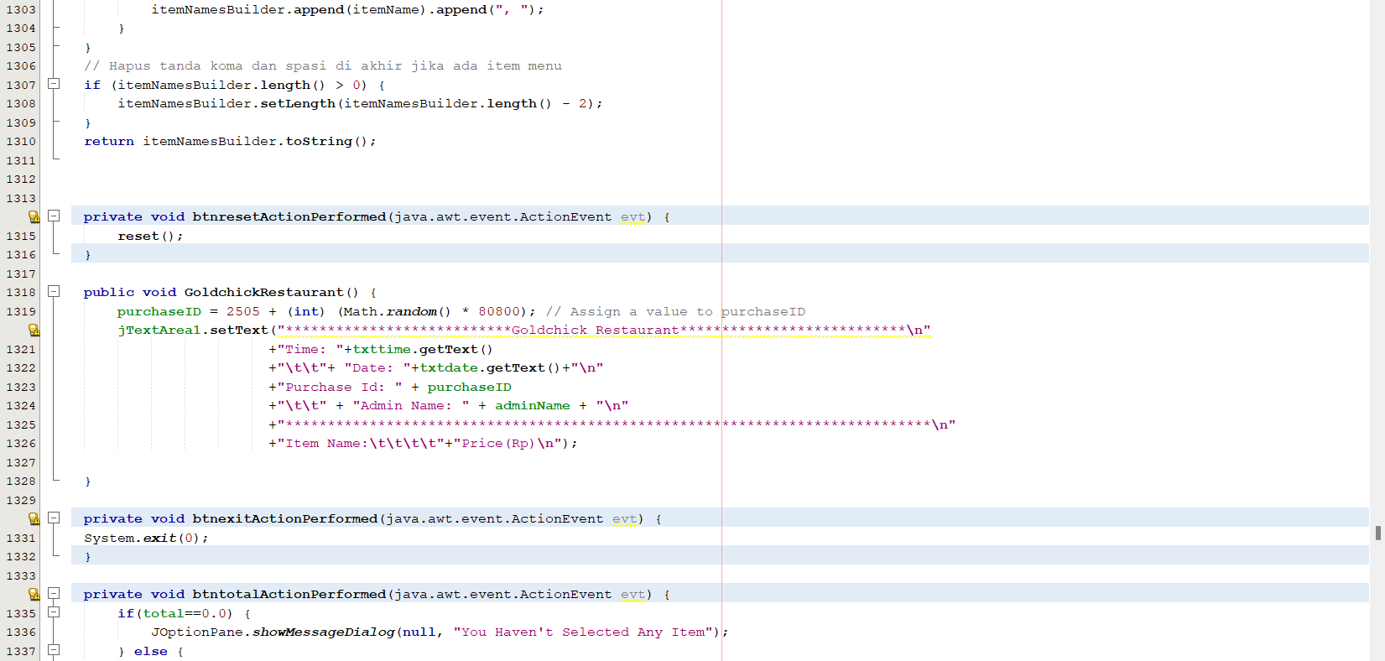

**SYSTEM PROCESS**

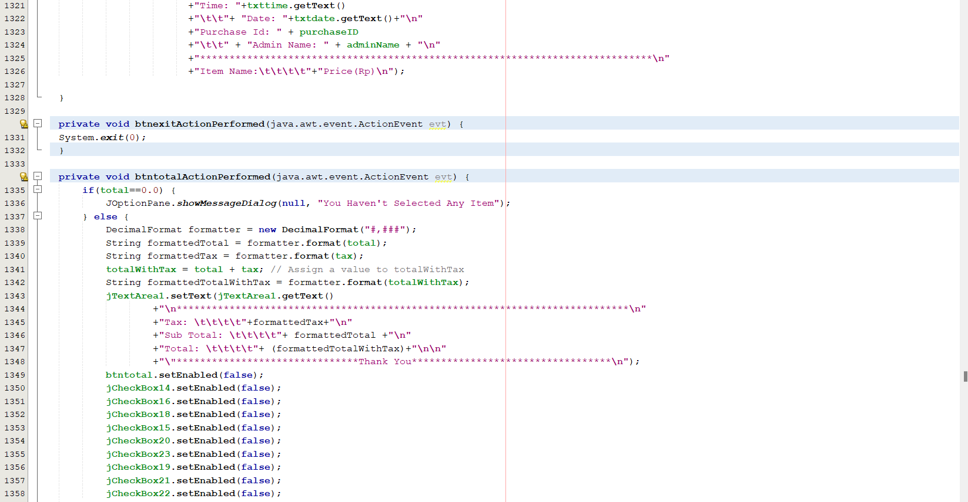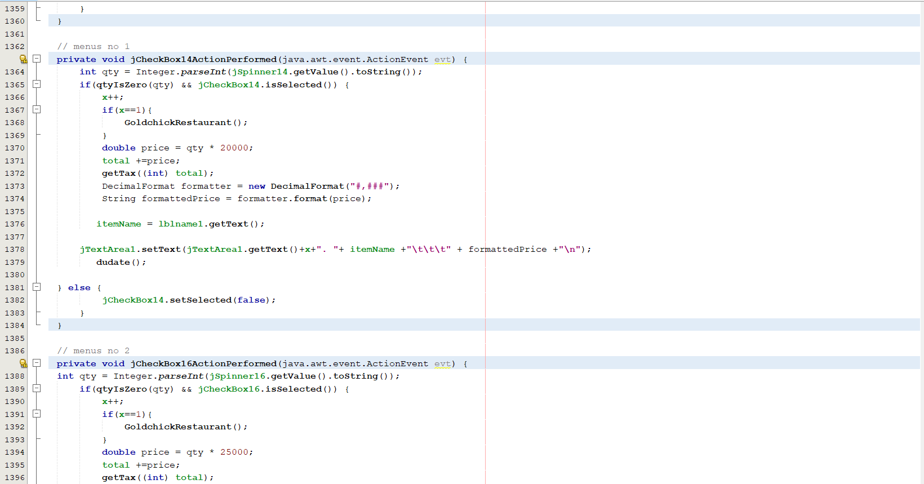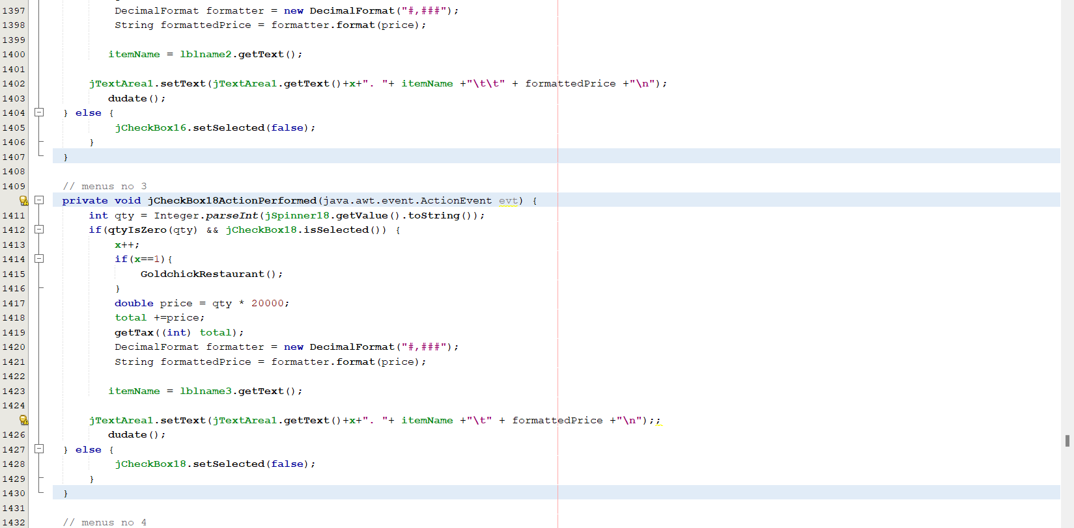

**SYSTEM PROCESS**

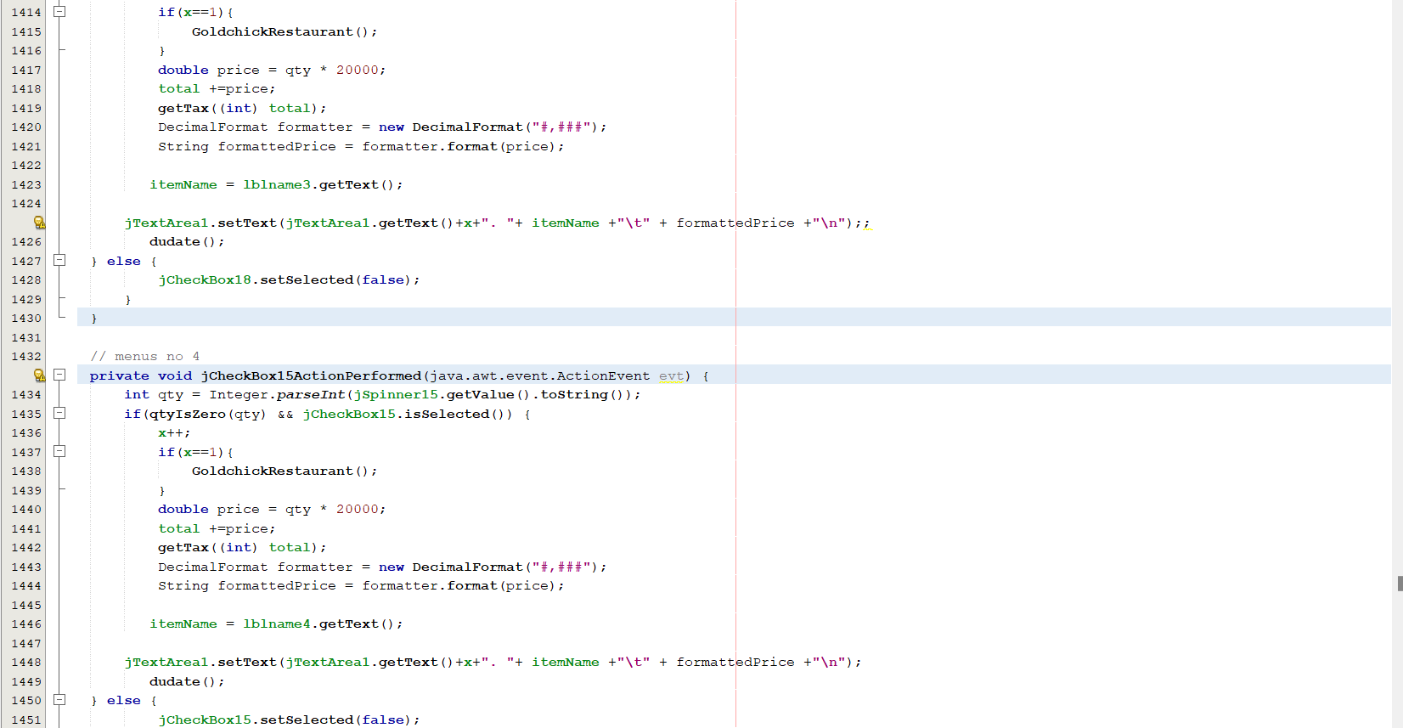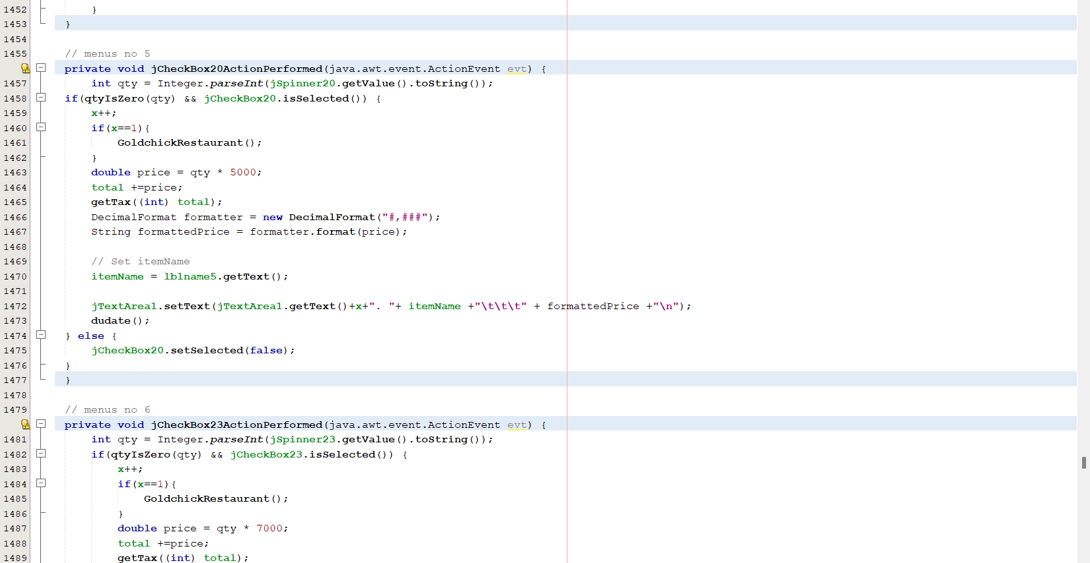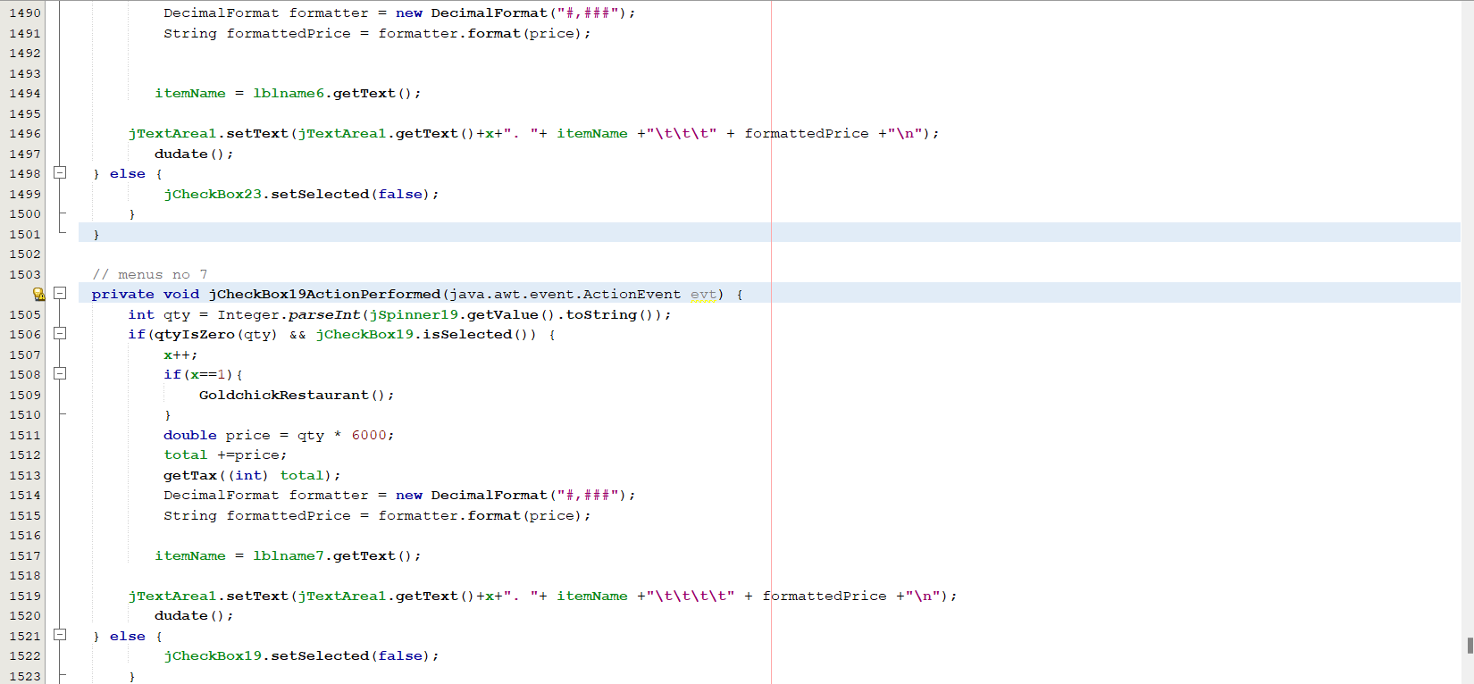

**SYSTEM PROCESS**

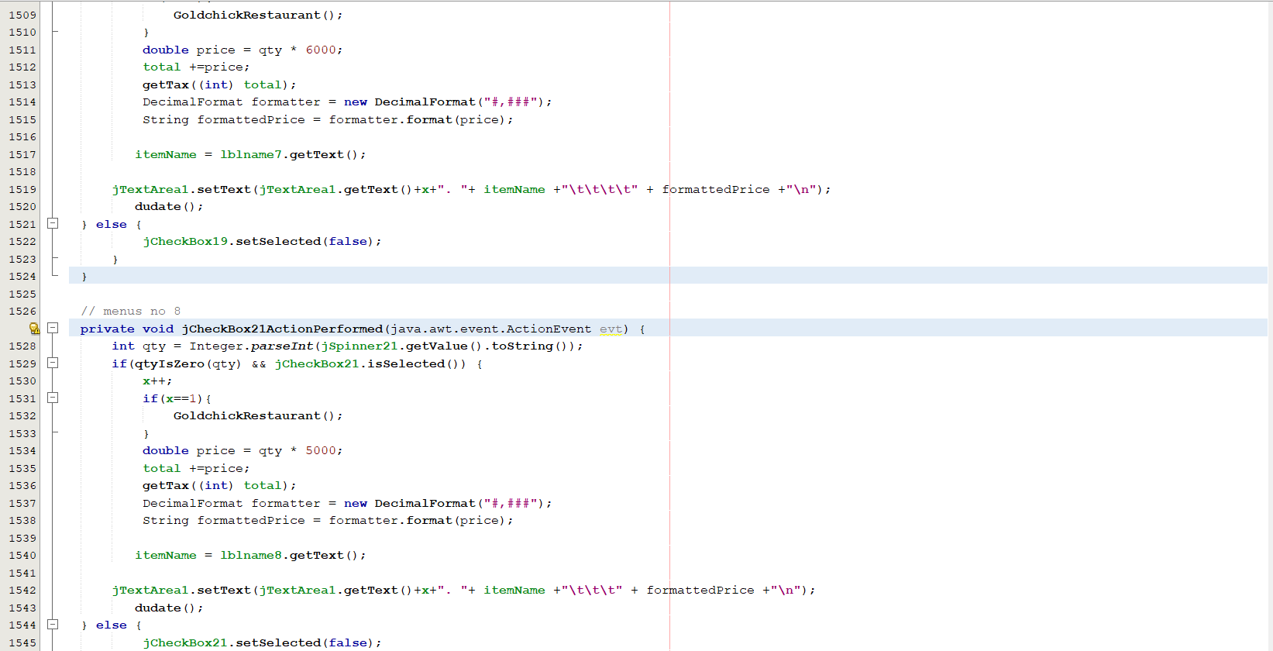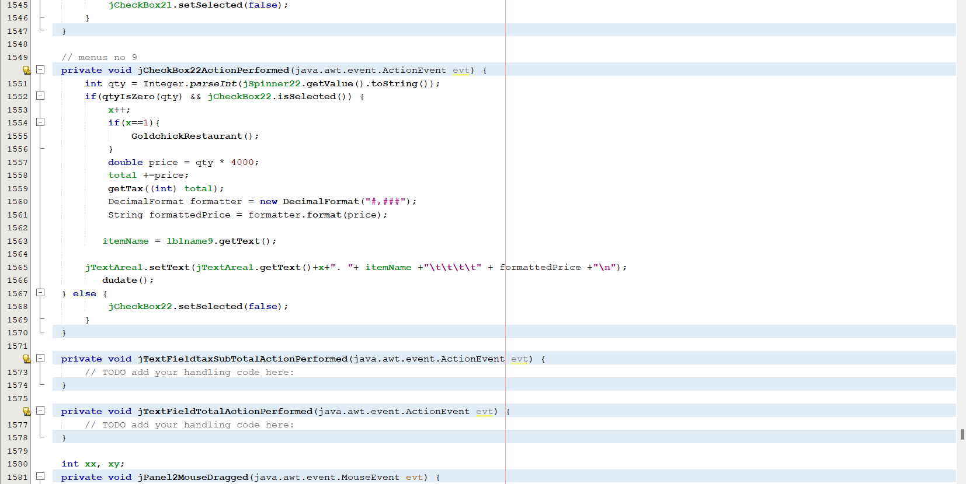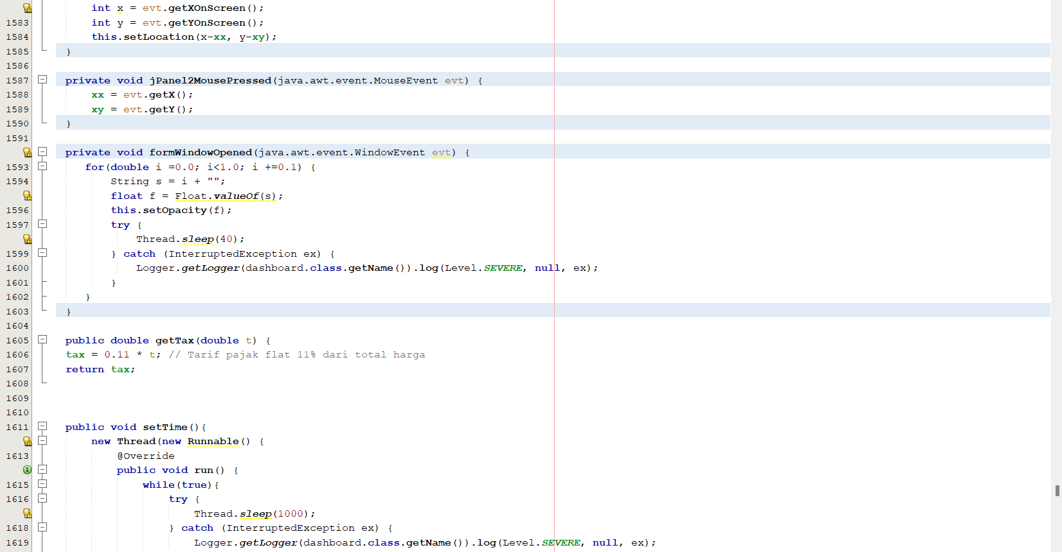

**SYSTEM PROCESS**

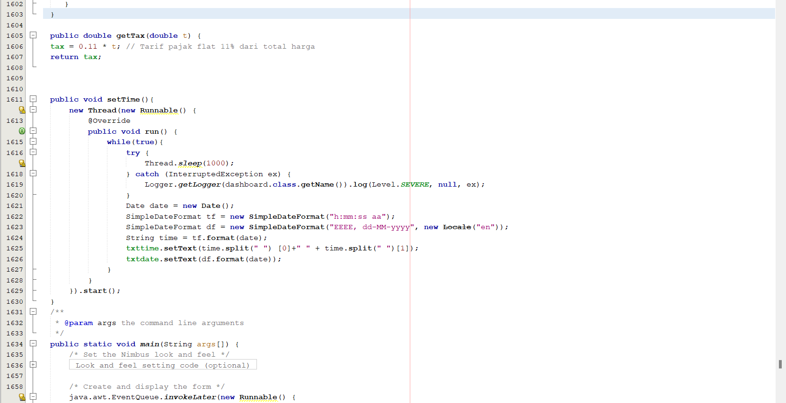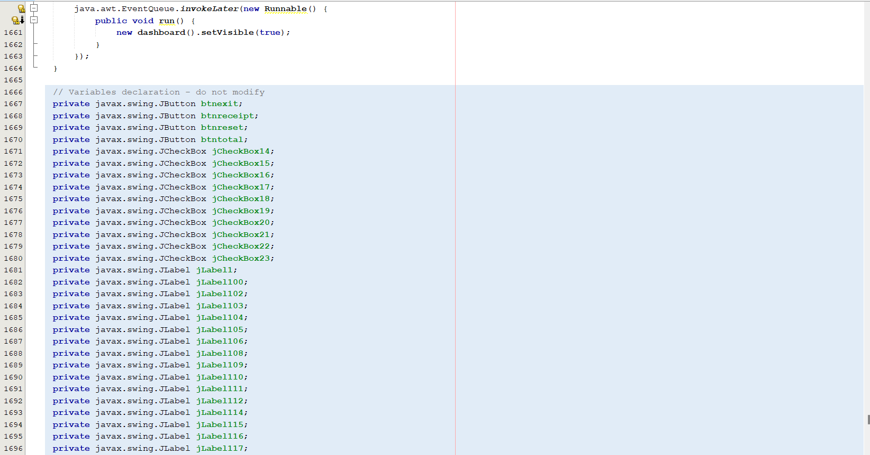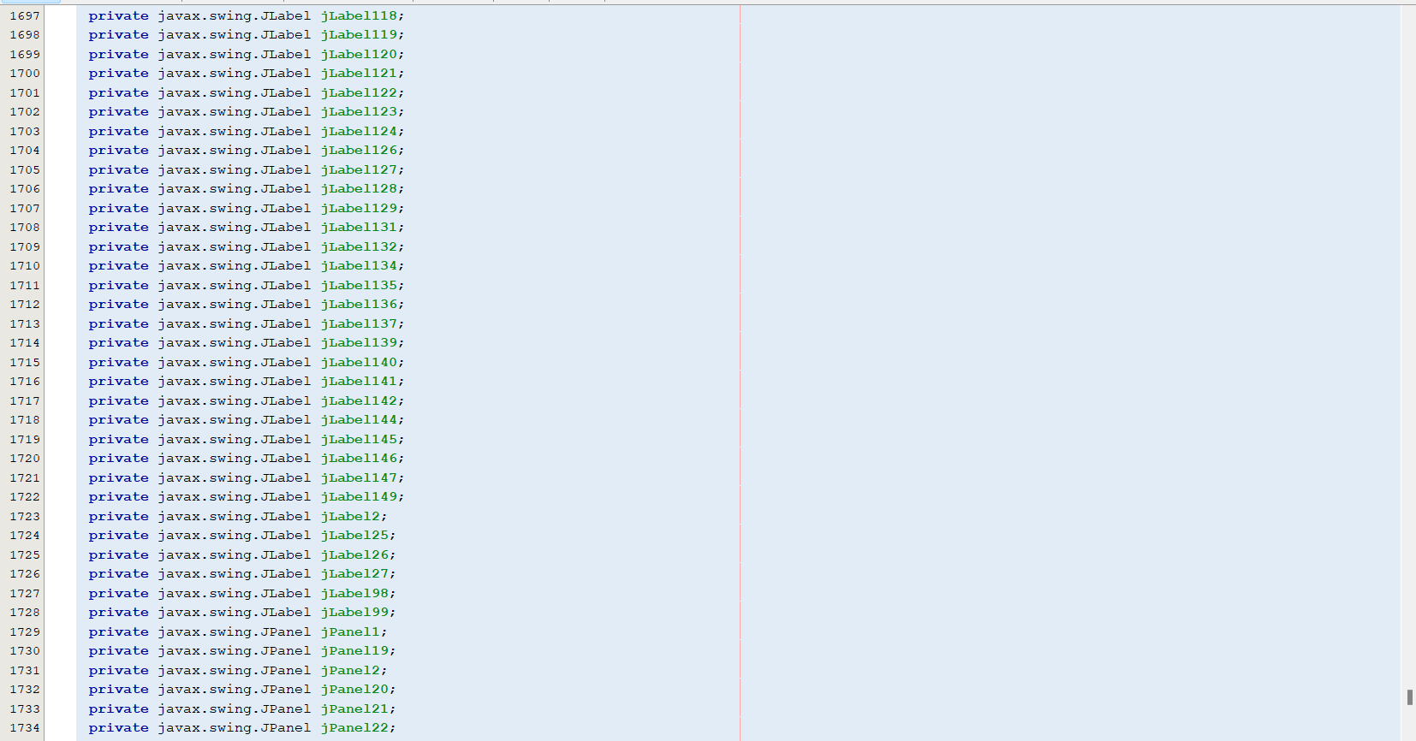

**SYSTEM PROCESS**

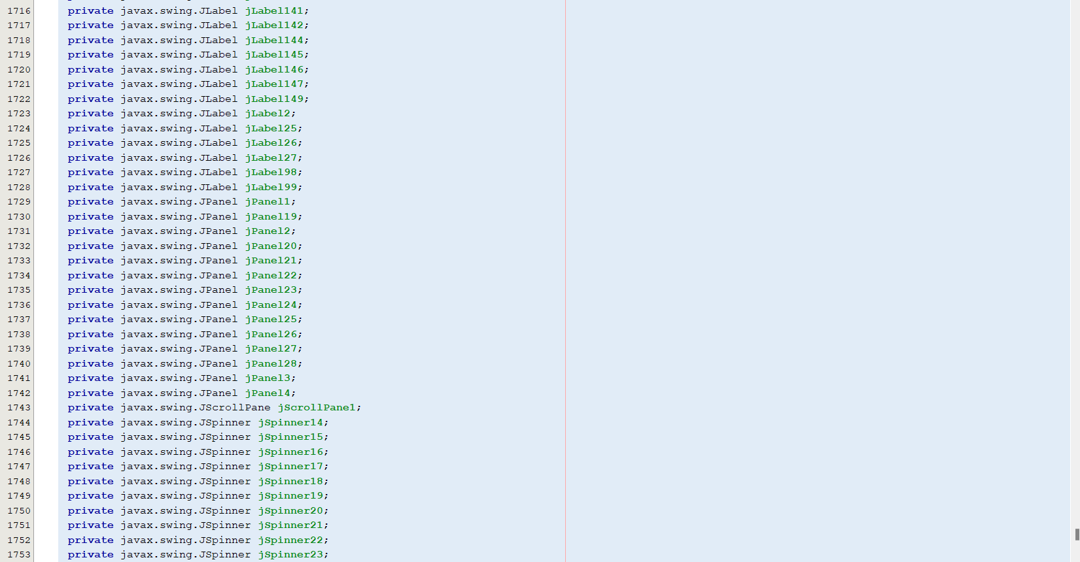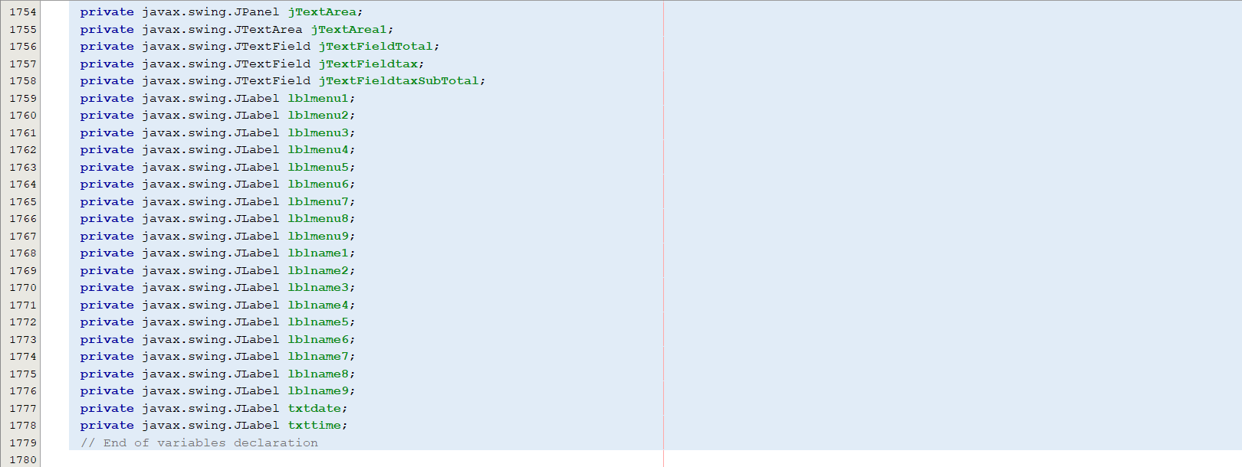

1. **Database Connection**

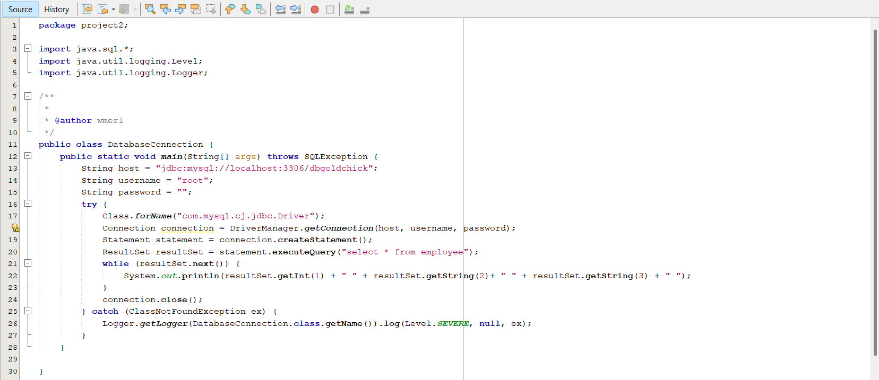

**SYSTEM PROCESS**

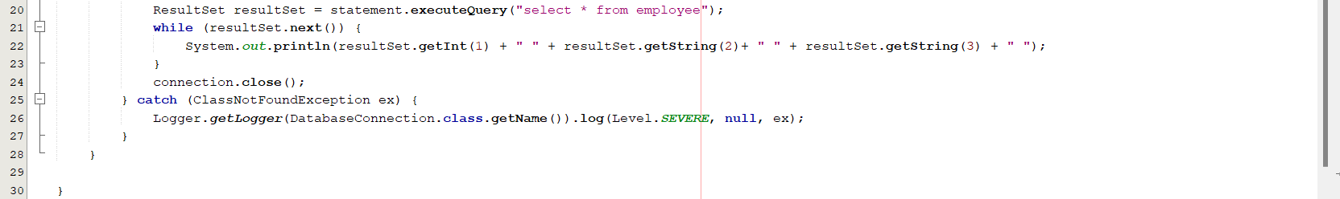

1. **TransactionDB**

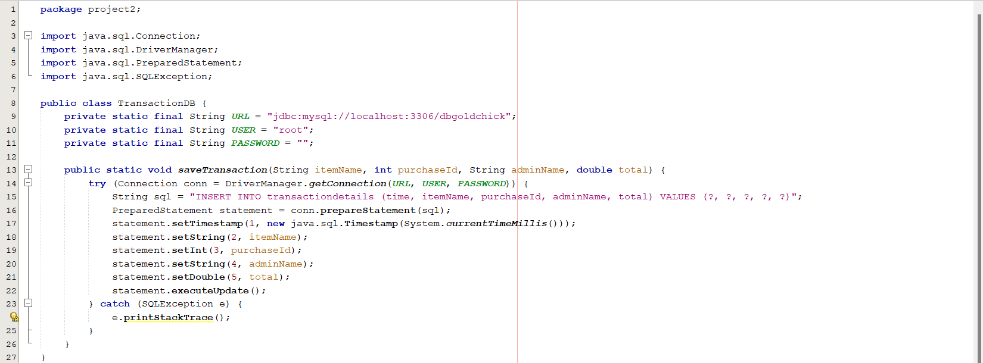

1. **Text Printable**

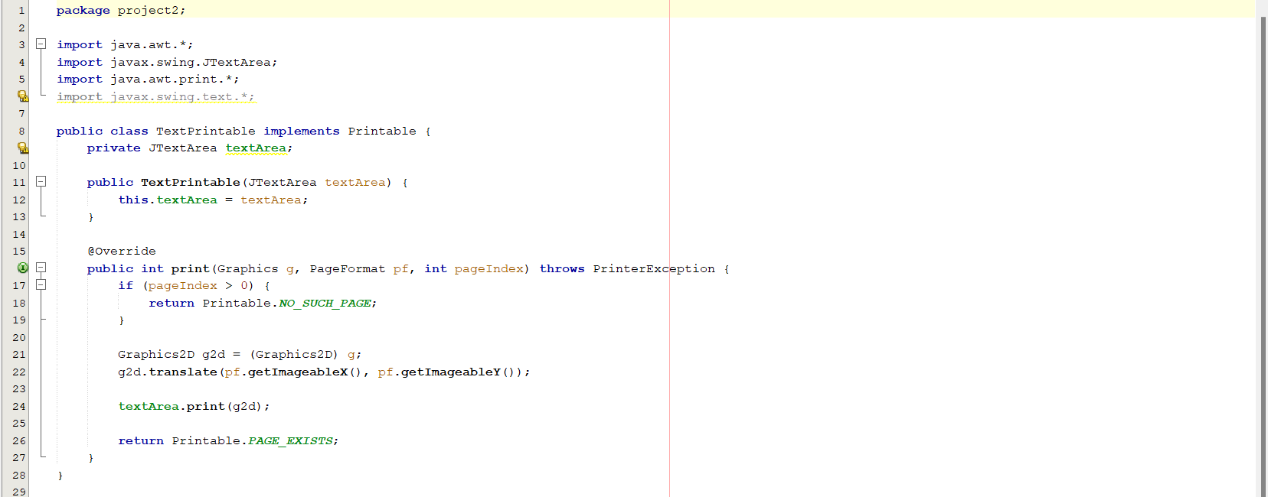

**SYSTEM PROCESS**

1. **SQL**

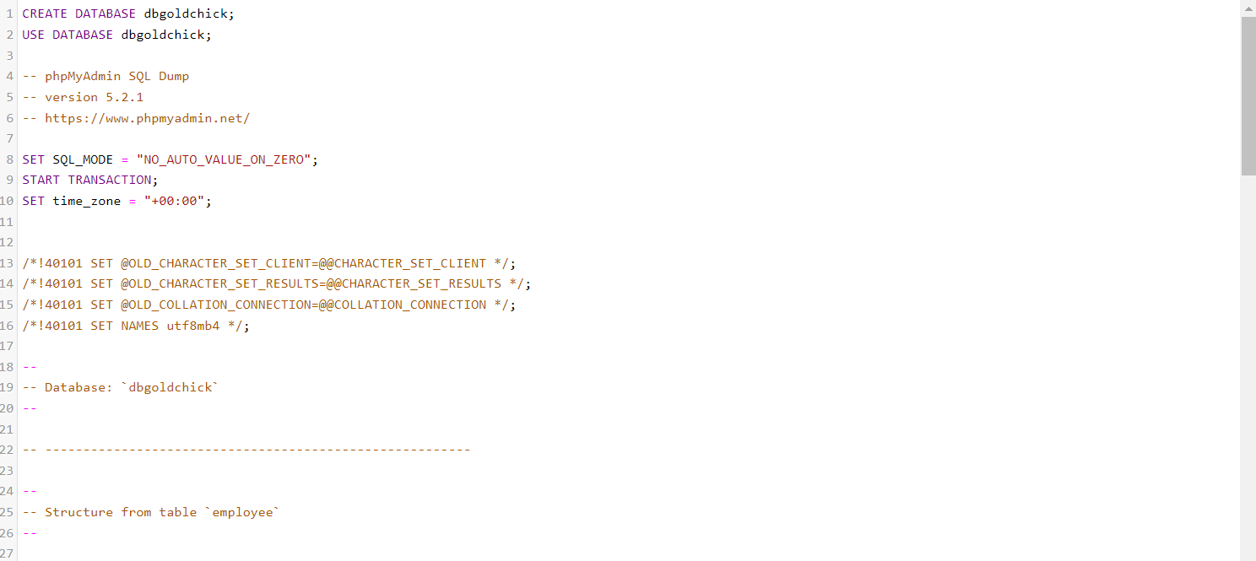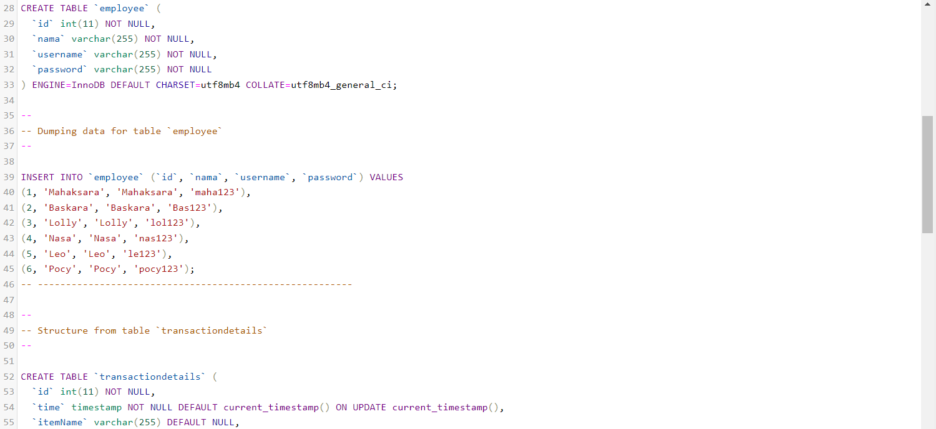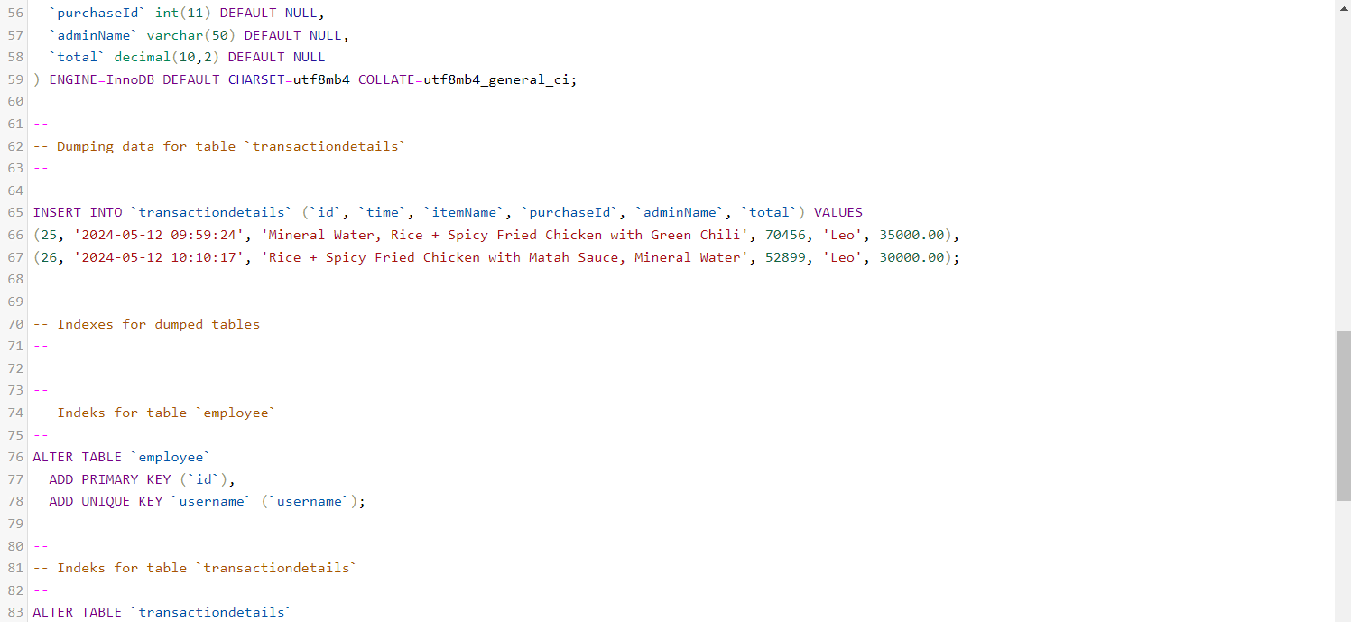

**SYSTEM PROCESS**

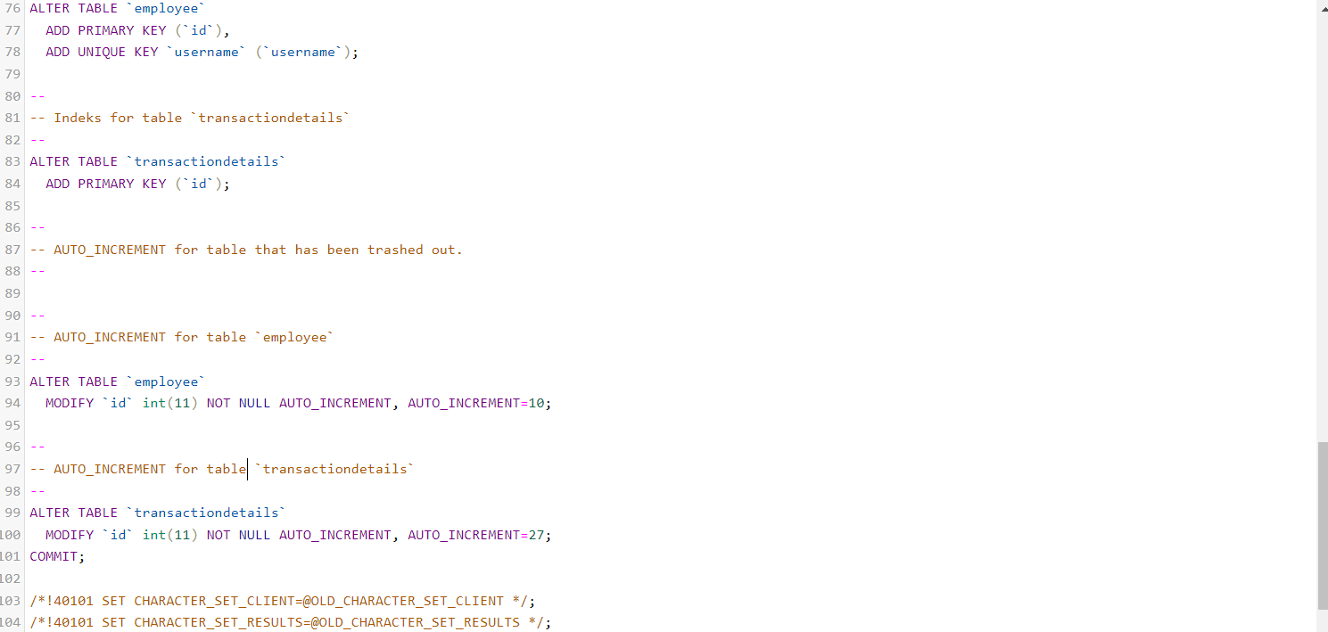

**OUTPUT**

1. **Login**
2. Input Username and Password

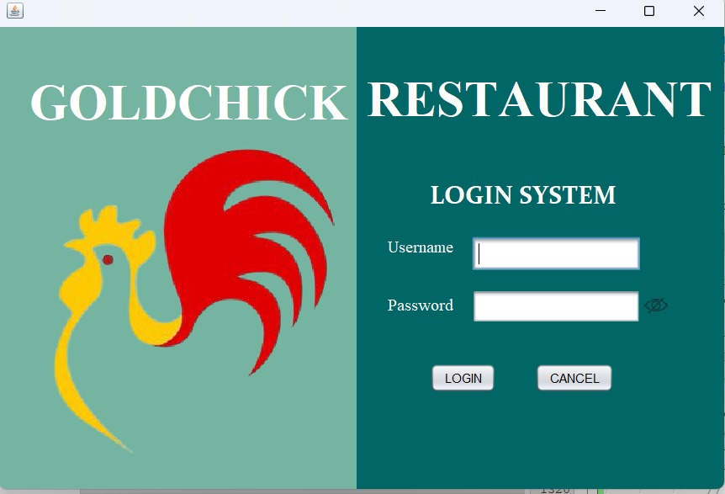

1. If the username and password do not match with the database, pop up warning will be appear.

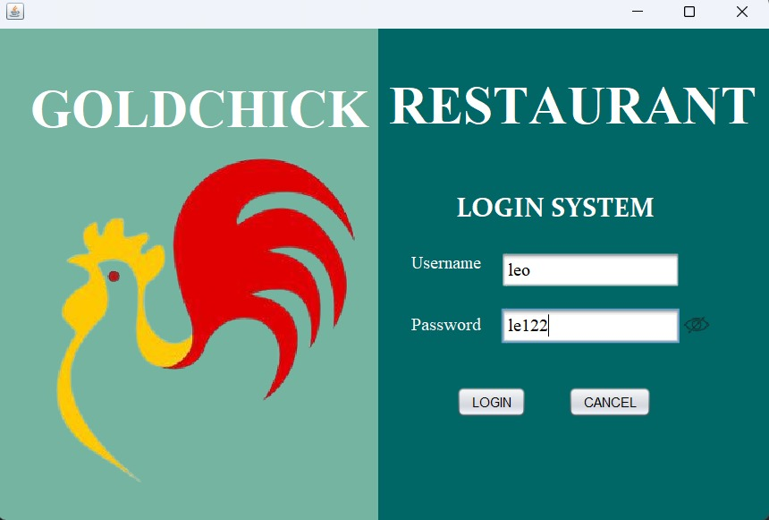 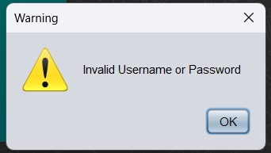

1. If username and password match, display dashboard.

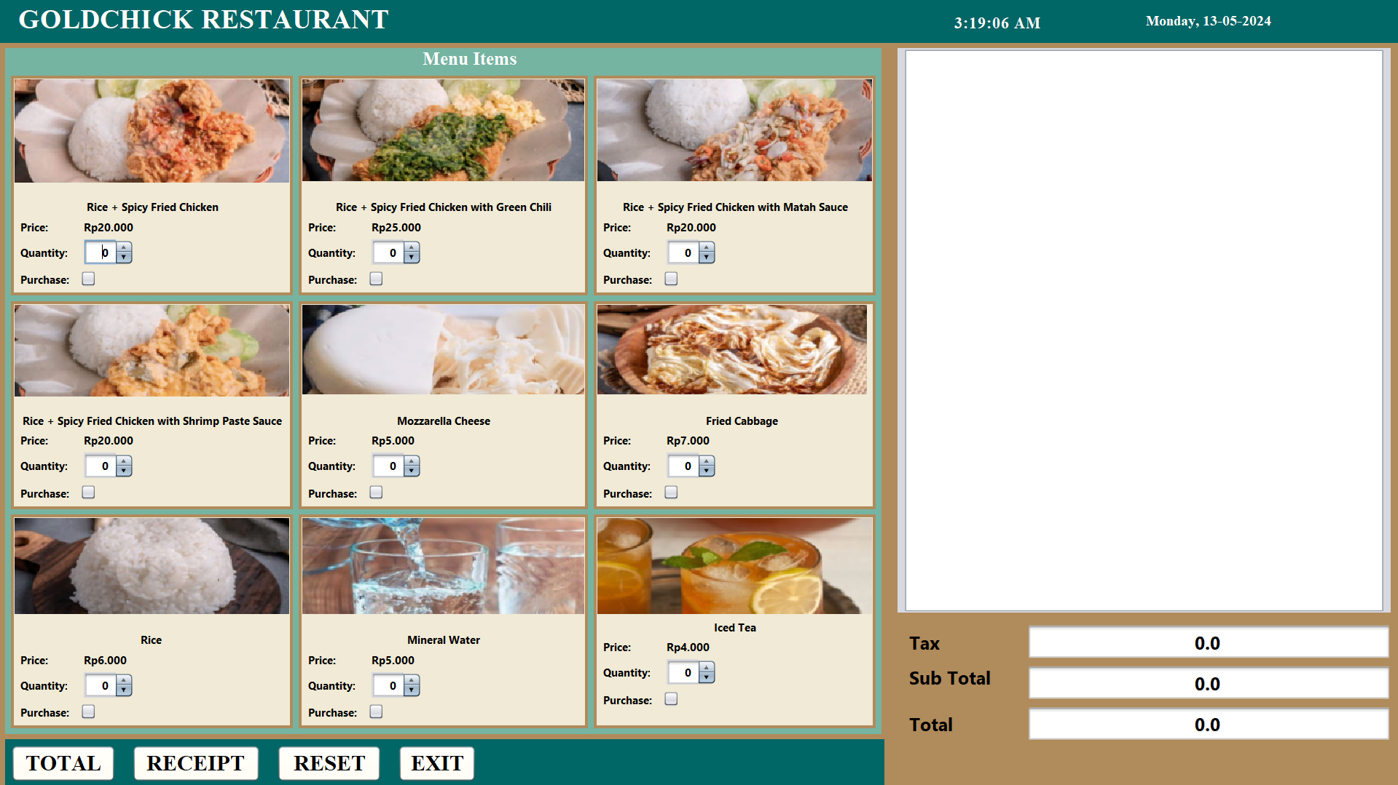

**OUTPUT**

1. **Dashboard**
2. The customer selects the menu and mentions the item quantity, in this example we take the Rice + Spicy Fried Chicken menu with quantity 2.

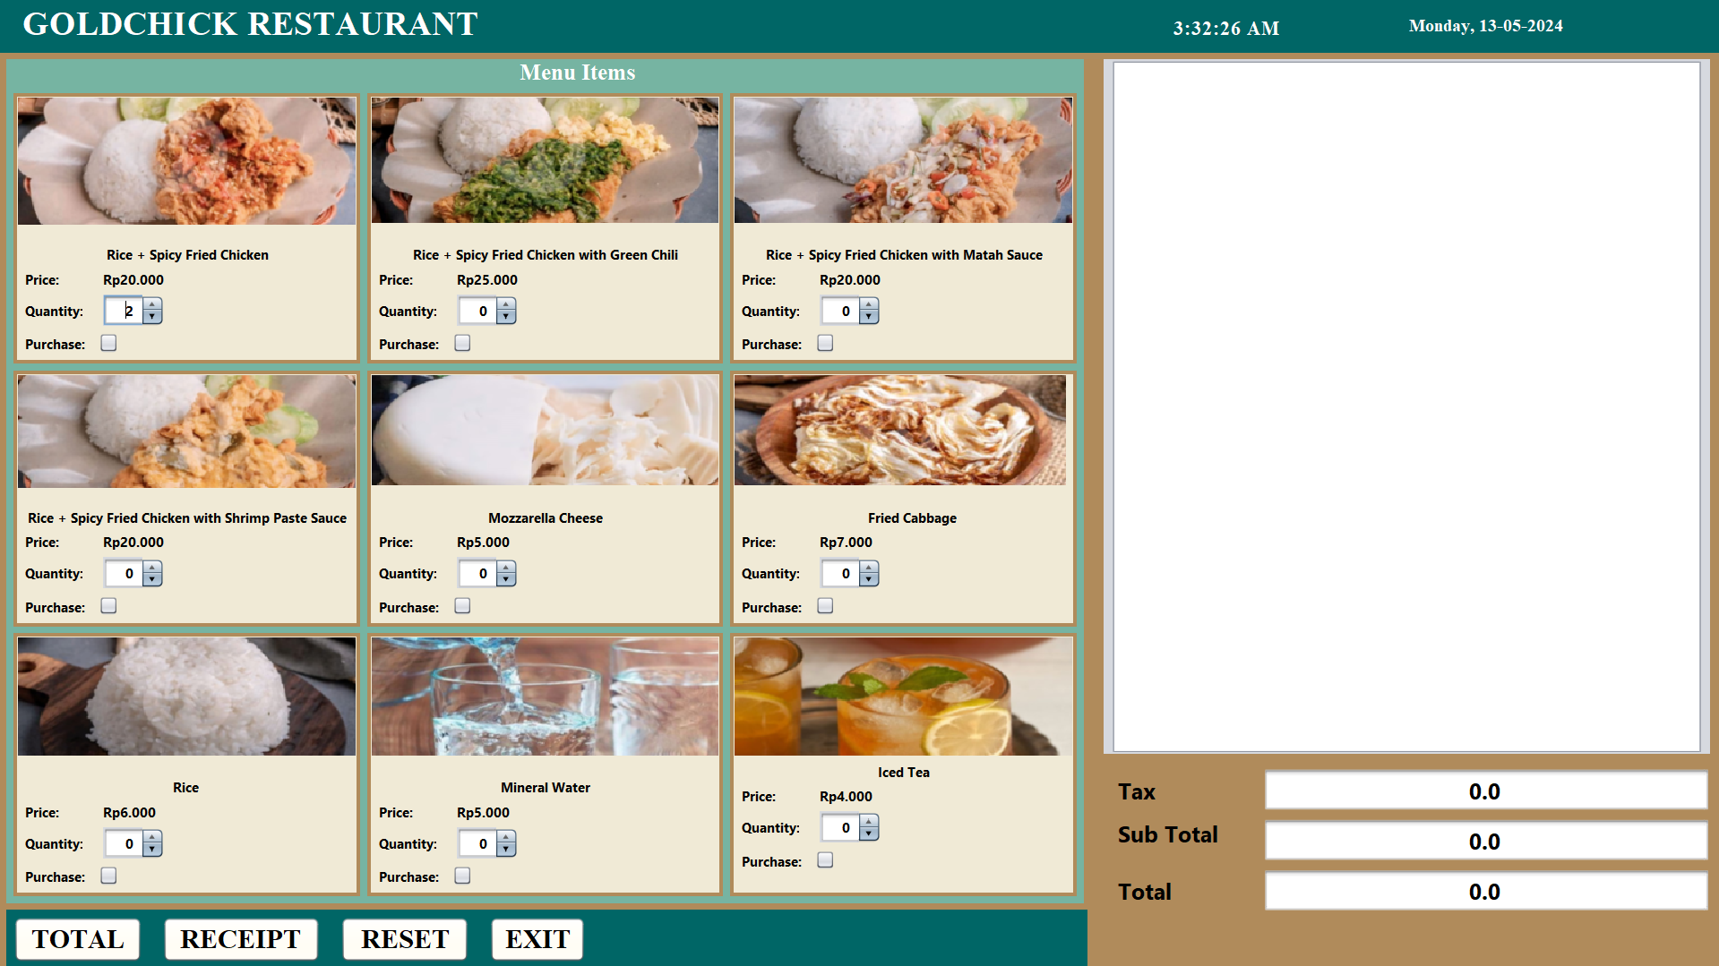

1. After that the admin presses the purchase button, and the menu will go directly into the receipt and automatically have the tax and total tax from each menu selected.

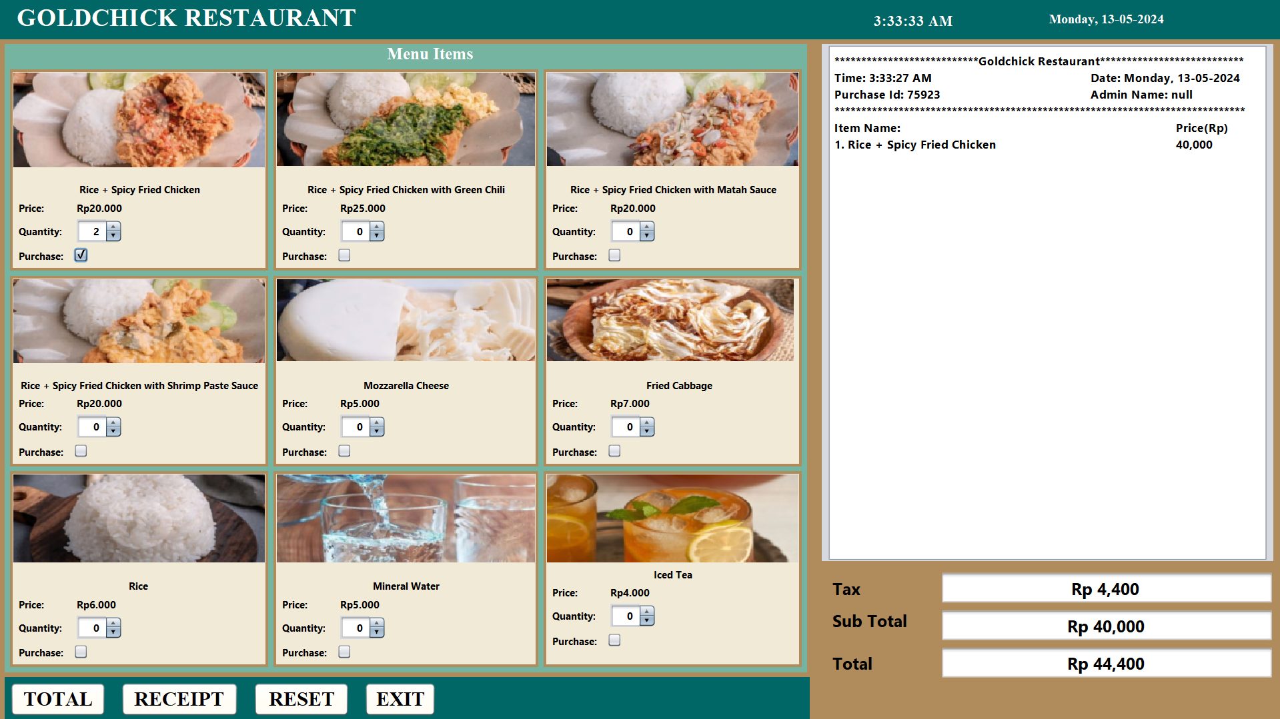

1. If the quantity entered is 0 but already pressed the purchase button, a pop up warning will appear

**OUTPUT**

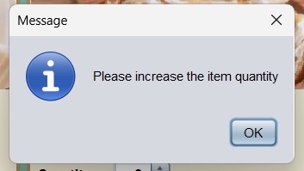

1. If you enter an item without pressing the purchase button and immediately press the total button, a pop up warning will appear.

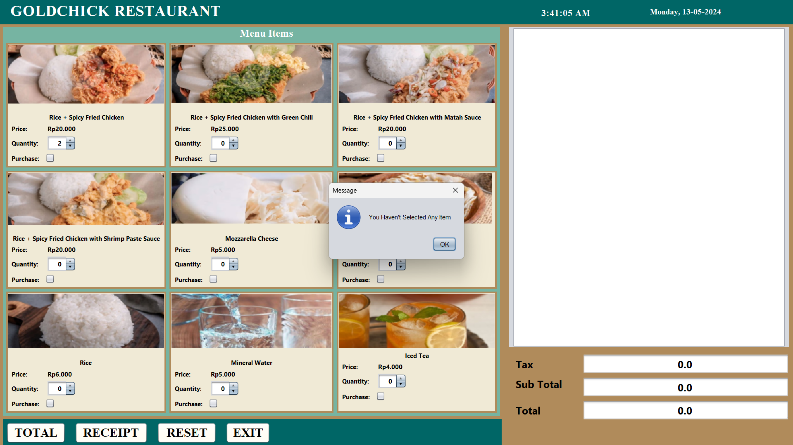

1. If you want to clear and select the menu from the beginning, press the reset button.

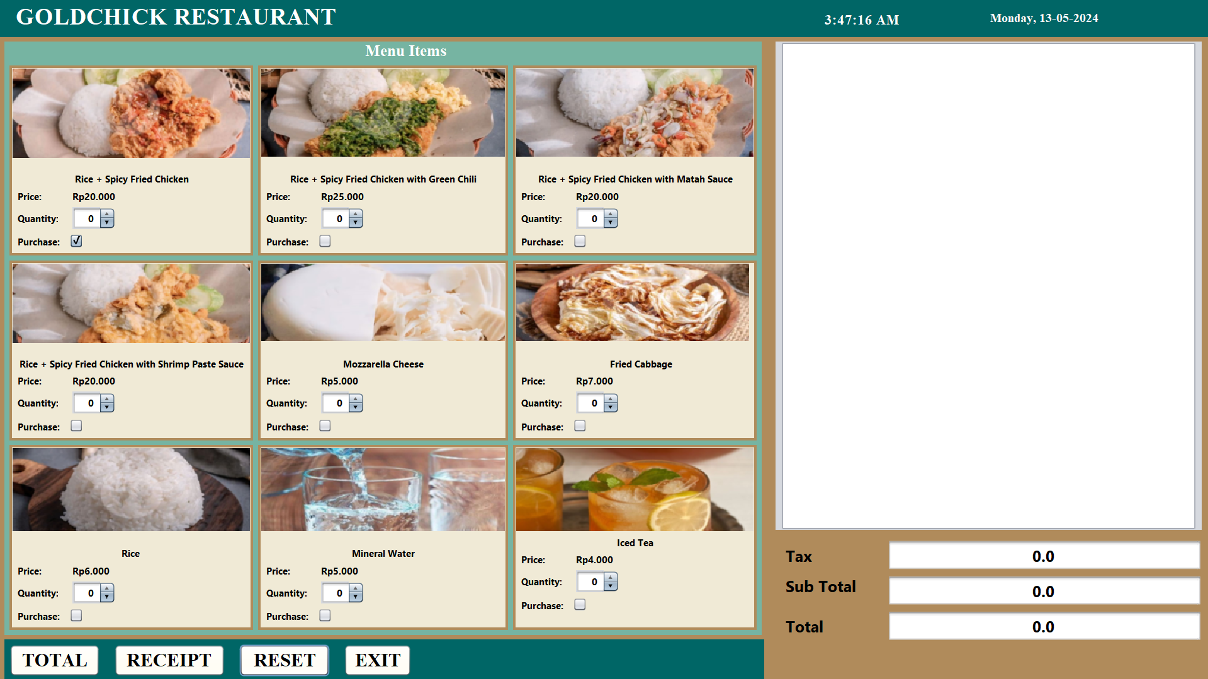

**OUTPUT**

1. Customer reselects the menu, here we take the example of Rice + Spicy Fried Chicken with Matah Chili with quantity 1.

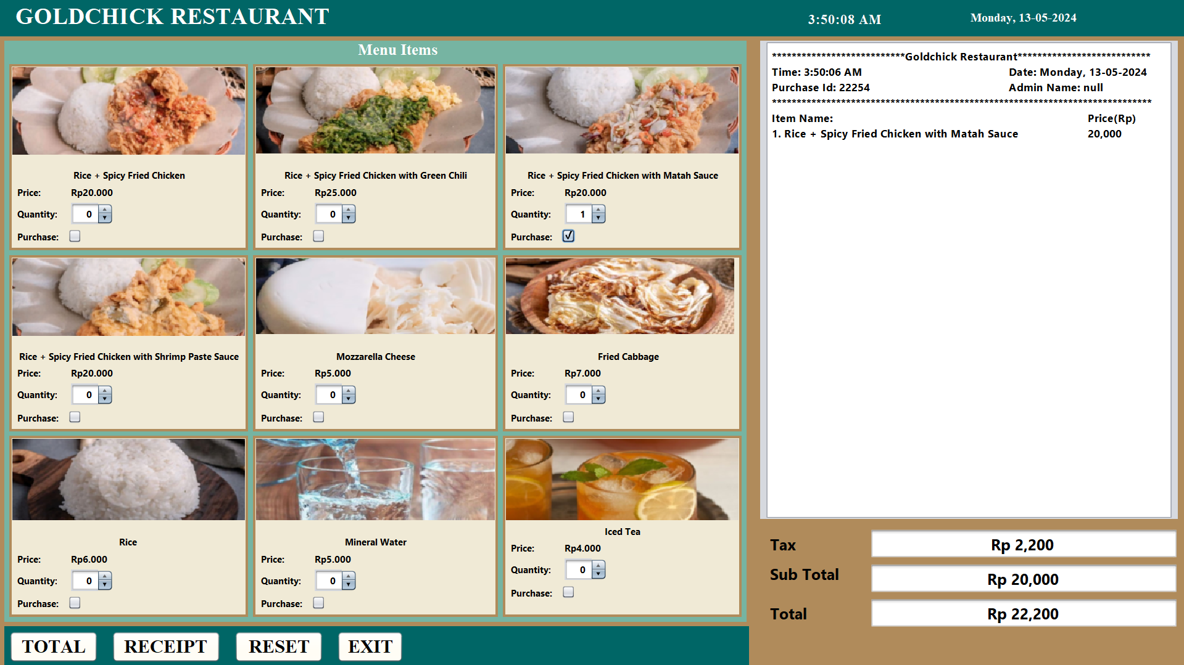

1. Then if the cutomer wants to select the menu again, select the menu again. For example, we take Rice + Spicy Fried Chicken with Shrimp Paste Sauce with quantity 1 and mineral water with quantity 2.

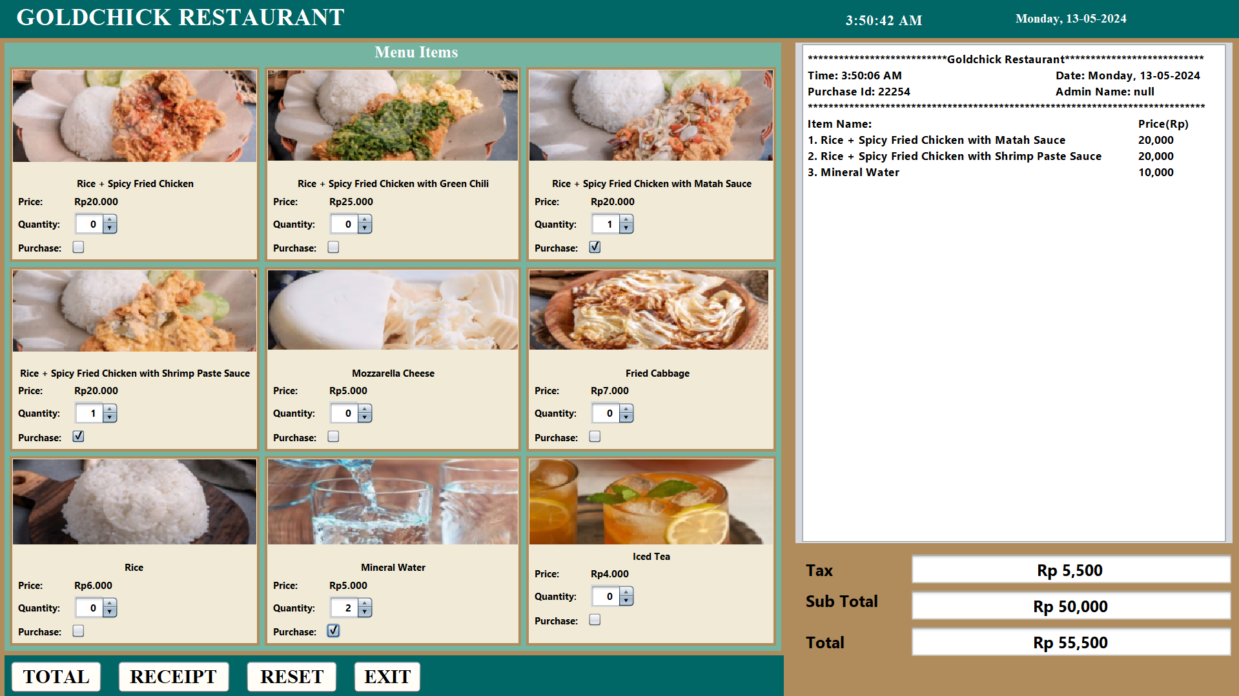

**OUTPUT**

1. If you have finished selecting the menu, press the total button then the tax, sub total, and total price will be entered into the receipt.

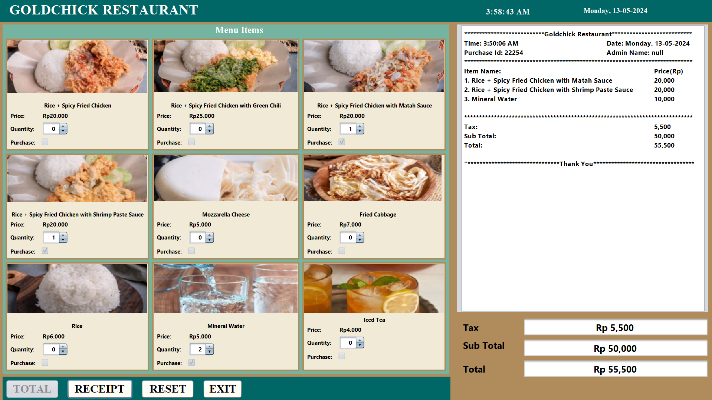

1. If you directly select the receipt button without calculating the total, a pop up warning will appear.

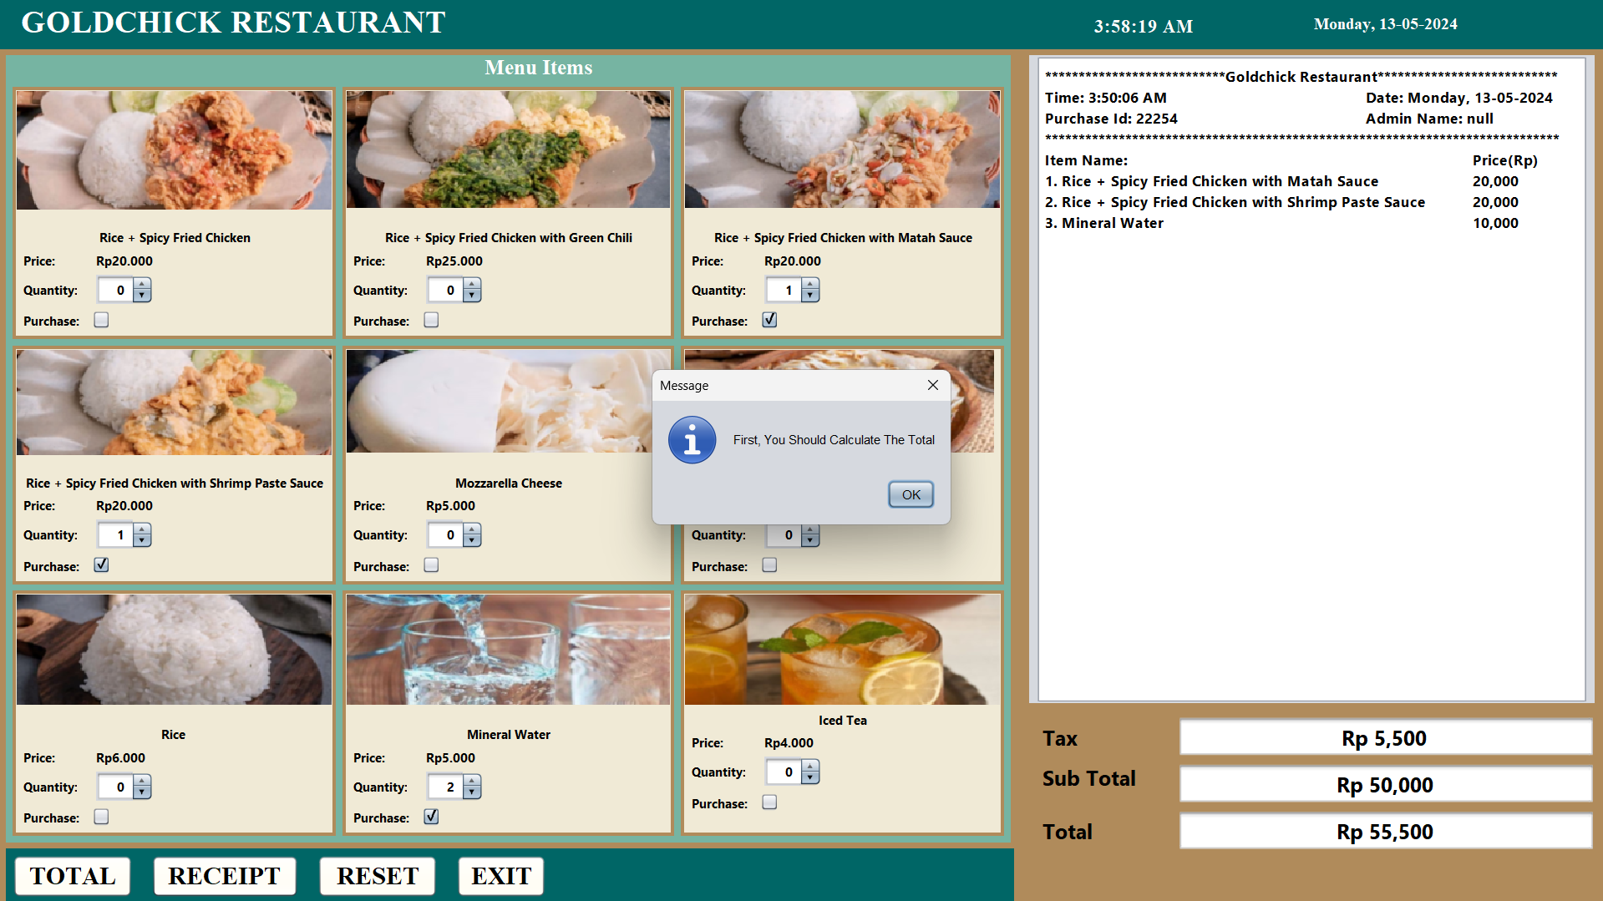

1. If you have done the total, press the receipt button, the receipt will be downloaded and then printed and the sale will be automatically entered into the transaction details database.

**OUTPUT**





**CONFIGURATION**

**Hardware :** Acer Aspire A715 – 76G 12th Gen Intel(R) Core(TM) i5-12450H

2.00 GHz 8,00 GB 64-bit operating system

**Operating System :** Windows 11 Home Single Language

**Software :** Apache NetBeans IDE 20, Draw.io, Google Chrome, Microsoft

Word

|  |  |  |
| --- | --- | --- |
| **PROJECT FILE DETAILS** | | |
| **No.** | **File Name** | **Remarks** |
| 1. | Diagram_Class.jpeg | Made with draw.io |
| 2. | login.java | Made with Apache NetBeans IDE 20 |
| 3. | dashboard.java | Made with Apache NetBeans IDE 20 |
| 4. | DatabaseConnection.java | Made with Apache NetBeans IDE 20 |
| 5. | TransactionDB.java | Made with Apache NetBeans IDE 20 |
| 6. | TextPrintable.java | Made with Apache NetBeans IDE 20 |